Final Thesis
An Extensible Visual Editor for Embedded Systems Specification Models
by
Jirong Zhu
LiTH-IDA-Ex-/
2003-0-

ABSTRACT

Nowadays, embedded systems have been widely used everywhere, and the design complexity is growing with the more and more advanced technology. A very important aspect in embedded systems design is their specifications that describe what the systems have to do.
The specification should provide criteria for the systems to be designed. The criteria are formulated in a specification language, which is kept preferably on a high abstraction level and, for example, need not be executable. The specification gives a formal model by class-library extensions, by this way to ensure the consistency of the systems and define the properties of the systems.
In many modern applications, graphs play important role in representing the specifications of embedded systems. The richness and practical purposes are needed by the specifications. The richness comes from several resources, which have the variations in the way of different types of graphs. Besides the general graph, there are Conditional Process Graph (CPG), Petri nets and other types of graphs.
It turns more difficult to work on these graph representations in a textual format since now the embedded systems become more and more complicated. We need to develop a visual editor, which users can design and edit the graph visually based on certain form of specifications.
There exist some kind of editors for graphs, but they each mostly focus on one type of graph at a time. If new graph is introduced, they cannot work any more. So we propose an extensible visual editor, which can edit many types of graph with their own specifications that are defined in formal ways. All the representations in the editor are graph-based and they share common concepts such like edges and nodes. By this way, the editor becomes extensible and it is not simply the combination of several editors.
In this thesis, we propose software architecture of the extensible visual editor and also the structure of the graph-type specification files. We give the examples of specification files for general graph, CPG and Petri nets. And then, we provide a implementation prototype of an editor for CPGs.

Acknowledgement

I am thankful to Petru Eles and all my colleagues at Embedded Systems Lab for providing me a pleasant working environment. My special thanks to Paul Pop whose keen supervision and invaluable guidance at every stage helped me a lot in carrying out this thesis work.

Contents

ABSTRACT 2
Acknowledgement 5
Contents 1
1 Introduction 3
2 Embedded Systems Design 7
2.3 Embedded systems design 8
2.3.1 Background information 8
2.3.2 Tasks of embedded systems design 9
2.3.3 Design flow 9
3 Specification Models 11
3.1 Introduction 11
3.2 Specification models based on graph structure Architecture 12
3.3 Conditional Process Graph (CPG) 14
3.4 Petri nets 19
3.5 Others 20
3.6 Specification Examples 21
4 Related work for the graph editor 22
4.1 Graph drawing/editing tools 22
4.2 Graph libraries 24
4.3 Functionality and limitation 28
5 Extensible Visual Editor 31
5.1 Introduction 31
5.2 Functionality of an extensible visual editor 32
5.2.1 General Graph Editor 32
5.2.2 CPG 35
5.2.3 Petri nets graph editor 36
5.3 Software structure of the editor 38
6 Specifying the Specification Models 43
6.1 Modeling graph types 43
6.2 Specifying the action types 43
6.3 XML specification files for the graph types 46
6.3.1 General Graph: 46
6.3.2 CPG: 47
6.3.3 Petri netss: 49
6.4 Descriptions of the XML specifications 50
7 Prototype Implementation 51
7.1 Implementation of CPG editor 51
7.2 Description of the implementation by UML 58
8 Conclusion & Future work 59
References 60
Appendix A 62
Behavioral_model.XML 62

1 Introduction

  - Contributions

The goal of this thesis is to design an extensible visual editor in order to be able to load and edit different types of graph according to variant embedded systems specifications that are specified before in the application. The specification can be written in plain language to generate a text file, or in formal language such as XML, depending on the practical requirements about the application.

Based on these variant specifications, the editor can load different graphical user interfaces working on such like general graph, CPG, Petri nets and some other types of graph. Then the users can open, edit and save the certain type of graph model through the loaded menus and tool bars. It is an extensible graph editor because of the functionalities in rich types of specifications and user graphic interfaces. All these are done by only one universal editor, but through different “sub-editors” that could be loaded by such technology like plug-in.

Due to the similarities in the design of each “sub-editor”, we build an implementation prototype of the extensible editor only for CPG in this thesis, to show the main functions and how to create and use it.

Mainly in this thesis the Contributions are the following:

- Analysis the graph editors that now are commonly used about the merits and the limitations. We talk about two examples: GEF and JGraph, to make the users clear about their practical categories in usage.

- Create the specifications specified by text or XML language and so on, based on the graph structure models and depends on the practical requirements of the application.

- The editor is extensible, so besides normal graph, CPG, Petri nets that we explained in details in this thesis and the other types of graph, even the new type of graph can be edited in the extensible editor, as long as we first define the matched specifications.

- Present the software architecture of the visual editor, including what are the basic and necessary components and how they interact to each other.

- Implement a visual editor prototype for CPG.

  - Overview

Embedded systems are now everywhere applied at present with more and more technologies in design, but the difficulties are increasing at the same time. As an important part of the embedded systems design, the system specifications need to be created as a start. The specification is a behavioral description of the system and specifies the requirements for a system, and it includes both functional requirements ---- the operations to be performed by the system, and non-functional requirements such as speed, power and manufacturing cost [10]. The specifications should be implementation-independent, that is to say, the specification is composed without any implications about the structure of the implementation [8].

The system is called 'correct' if the criteria specified inside the specification are satisfied. These criteria are formulated in a specification language, which is kept preferably on a high abstraction level and, for example, need not be executable. The specification language should support the creative development of the specifications. Formal or informal specification languages can be used by the designer to specify the intended behavior of the system and mapped into the system model later in design flow.

Specification models can be sorted into different categories by what they mainly focus on. Among them, graph-based representations are the most popular in embedded system design. For instance, Petri nets are a kind of state-oriented specification model; CPG is a kind of activity-oriented specification model; and we have many other graph representations like state charts and so on.

Since now the systems are getting more and more complicated, it is more difficult to go on with the design if the embedded systems specifications are represented only in textual formats. So we need to make the embedded systems specifications in a visual way.

There have already some graph editors being designed for different types of graphs. For example, Predator editor and GrapE are especially for Petri nets; and there are variant kinds of editors for general graphs, which always have different emphasis in design. For CPG it is good to use project JGraph (Project website: http://jgraph.sourceforge.net/), thus we implement a prototype of the CPG editor by generalizing the basis object classes from JGraph later in this thesis. But if the users need to edit variant types of the graph at one time, they have to load different visual editors. So it is very practical to extend the graph editor due to the embedded systems’ design demands.

Since almost all the graphs share some common properties and attributes on the nodes, edges and etc. we can provide a new extensible visual editor solving the above problem. Even with the new type of graph that we never meet before, because of the similarities in the graph property, we can just based on the original library of the extensible editor and extends the corresponding classes to implement a prototype for the new type of graph. Under the instructions of the respective specifications for each kind of graph, through kind of plug-in technology, the editor is extensible with displaying different toolbars, menus automatically when loading the graphs.

To design the extensible visual editor, we discuss the software architecture and the structures of the graph-type specification files. In addition, we give the examples of the specification files for general graphs, CPGs and Petri nets each in the thesis. And then, one implementation prototype of an editor for CPGs is also available with the basic functionality----open, edit and save.

The purpose of this thesis is, first, we give the background information of embedded systems and embedded systems design. And the general theories of specifications, also the specification models based on the graph structure including conditional process graph, Petri nets and other kinds of graphs. We can present the graphs in XML specifications according to the examples, indicating the attributes of the nodes and edges. But there is one thing, in the prototype of CPG editor, the specification is defined by informal specification language currently, in textual form.

Second, the description of the extensible visual editor is given by explaining the concrete functions and its software architecture. We analysis what are the components of the software architecture and how do they interact with each other. In addition, we give the graph project JGraph and GEF as the examples.

Next, we focus on the structure of the specification models. The concepts that should be specified need to be discussed, and respectively XML specifications shall define the models for different types of the graphs mainly about general graph, CPG, and Petri nets.

Last, we give a practiced part of the visual editor, for example, when loading the CPG specification file, the graph would be presented in the editor pane and then we can do operations on the graph through the tool bar and menu bar that are displayed automatically at the time of loading. Of course we can also save the graph in form of specification file that in this case is a text file with the name .cpg.

2 Embedded Systems Design

2.1 Definition of embedded systems

Embedded Systems are now everywhere and omnipresent, ranges from microwave ovens to aircraft-control systems. Almost all the devices we use, from cellular phones to pages, from microwave ovens to PDAs, are controlled by embedded system.

Embedded system is a specialized computer system, which is a part in a huge machine or system. It is designed for a particular kind of application device being fixed either in capability or programmable. It implements system functions by running software on programmable computers and it has programmable instruction-set processors with the programs stored in ROM. So usually an embedded system is the combination of computer hardware and software. Some embedded systems also include an operating system.

The simplest embedded system could be a single microprocessor (chip). Because microprocessors can be used in such a wide range of products, embedded system may need to meet widely divergent criteria. The embedded system can be used to control, monitor or assist an operation. It can also be controlled by external software as in a client/server environment.

2.2 Main characteristics of embedded systems

To be a design of a combination of hardware components and software programmable processors, which together form a part of a larger machine and interact with each other, embedded systems have these characteristics:

- Complex functionality, embedded systems often have to run complicated algorithms or multiple algorithms of software on programmable computers and provide complicated user interface.

- Real-time operation, embedded systems often have either hard or soft deadlines in completing the operations. Soft deadline can’t be exactly determined but if the system fails to meet soft deadline, system performance could be degraded. Hard deadline must be fulfilled. If any hard deadline is missed in any time, system is in fault.

- Multi-rate, the operations are handled at widely varying rates in embedded systems. Embedded systems are multi-rate.

- Low manufacturing cost and low power, embedded systems must have low manufacturing costs to increase the market usage. And too much consumption in power of embedded systems increases the cost. So power consumption also becomes critical to evaluate the system performance.

- Designed to meet tight deadlines by small teams, embedded systems are often designed by a small team of designers. Usually embedded systems must meet tight deadlines [12].

2.3 Embedded systems design

2.3.1 Background information

The design of embedded computer system uses software running on a hardware platform to implement the system functions. Creating an embedded system, which meets its performance, cost, and design time goals, is a hardware-software co-design problem, that is to say, the design of the hardware and software components influence and integrate each other.

The basic goal of the embedded systems design is to implement some of the system’s functions on microprocessors and make one or more of those requirements easier to fulfill. Embedded systems shall need to fulfill widely criteria. We have different important design requirements on different systems among time, manufacturing cost, modifiability, reliability and so on.

Embedded systems design has its own specialties, which are different with the design for general-purpose computers or software application running on the machines.

The optimal desire method for embedded systems could be discussed for different cases. The design challenge is to simultaneously optimize numerous design criteria to achieve the relatively complete goal in time, performance and cost etc.

2.3.2 Tasks of embedded systems design

Embedded system design can be divided into four major tasks:

- Partitioning the function to be implemented into smaller, interacting pieces.

- Allocating those partitions to microprocessors or other hardware units, where the function may be implemented directly in hardware or in software running on a microprocessor.

- Scheduling the times at which functions are executed, which is important when several functional partitions share one hardware unit.

- Mapping a generic functional description into an implementation on a particular set of components, either as software suitable for a given microprocessor or logic, which can be, implemented from the given hardware libraries [10].

2.3.3 Design flow

As shown in Figure 1, the design consists of two flows; one is the mapping of the computational parts of the specification onto processing elements of system architecture, and the other is the mapping of the communication in the specification onto system busses. Each flow requires allocation of components, partitioning of the specification onto components, and scheduling of execution on the inherently sequential components. The result is the system architecture of process components connected via busses. Then each component is further implemented through software and hardware synthesis. [8].

3 Specification Models

3.1 Introduction

In methodical design of embedded systems, one key aspect is the creation of models. The models are the concrete representation of knowledge and ideas about a system being developed. The model may deliberately hide or change some details in the system but concretely give certain properties to be understood, analyzed and confirmed. By creation a system model, we can obviously dealing with the system complexity well.

Usually the creation of a system model starts after the specification. It can be considered as a connection between software application and hardware implementation. The system modeling hierarchically organizes components in synchronous or asynchronous communications.

The purpose of a model is to provide an abstract view of a system. As a model, the qualities are: it should be formal and no ambiguity, it should be complete, comprehensible, easy to model and neutral enough to aid. Models are easy to define, but it is hard to see their eventual effectiveness and limitations. Good models should be simple, executable, synthesizable, and have high expressive power. The model quality is tested in practice.

Generally, there are two types of embedded system modeling: system structure and system behavior. Behavior modeling tells what does the system do. In real time embedded system, behavior modeling meets temporal contract with the environment. Structure modeling is needed because the embedded systems often have complex high-level run time structures. Structure modeling gives the relationships between individual entities and communication objects.

The popular models for embedded systems are communicating finite state machines (FSM), dataflow, process network, Petri nets, object-oriented models, heterogonous models and so on.

Many designs in embedded system are usually based on heterogeneous architectures that integrate multiple programmable processors and dedicated hardware components. So we can use graph as an abstract syntax of the embedded system models with a useful visual representation. [13][17]

In this thesis, we mainly discuss the system modeling by graphs including general graphs, CPGs and Petri nets.

3.2 Specification models based on graph structure Architecture

3.2.1 Background of graph theory
A graph is a diagram constituting of a set of points connected by line segments, points are usually called vertices (V) or nodes, and line segments are called edges (E). For example any network can be represented as a graph.
A vertex (node) is a terminal point or an intersection point of a graph. It is the abstraction of a location. An edge e is a link between two nodes. A link is the abstraction of a transport infrastructure supporting movements between nodes. The link can also be directed or undirected, commonly we represent the directed link with an arrow.
Formally, a graph G is an ordered pair G = (V, E), where V is a finite, non-empty set of vertices, and E is a (possibly empty) set of unordered pairs of distinct vertices (i.e., 2-subsets of V) called edges.We say that vertices u and v are adjacent in G if e = {u, v} is an edge in graph E (G), and e joins u and v. we'll also say that u and v are the ends of e. We write uv or vu to denote the edge {u, v}, if no order is implied.

If in a graph there is only one edge joining a pair of vertices and a vertex cannot be adjacent to itself, this kind of graph is called Simple Graph. A simple graph has no arrows, no loops, and cannot have multiple edges joining vertices. In other cases, if there is more than one edge that connect nodes u and v, in other words, there are multiple or parallel edges, then it is called multiple graphs. Through different criteria in division, we have different graph categories, we can reference to [3] for details.

3.2.2 Example of a general graph
We use an example as the network consisting of the major tourist cities in China (see Figure 2), we just choose six famous ones from them which are Beijing, Xi’an, Shanghai, Chongqing, Guilin, Xia’men. They can be considered as six nodes in the graph. To facilitate the tourists, we connect these cities for each by line segments in order to show the distances by air.
The graph is represented in Figure 2.
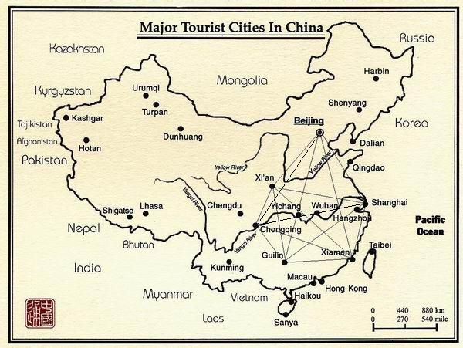
Figure 2. Map of the major tourist cities in China

Figure 3. Example graph of the network constitutes of six main tourist cities in China

The numbers on the lines are the direct distances between the six cities here, and the unit is km.

In this example, the graph we created is a very simple one, and each pair of nodes in the graph are connected by only one edge, so it is not a multiple graph and not a directed graph either because the airline is not single directed.

3.3 Conditional Process Graph (CPG)

3.3.1 Background of CPG

As we said the embedded system design is a combination co-design of hardware and software. It requires the representations for the software processes. a data flow graph is a good software model, which presents data sources and destinations between the processes, and shows the process states, their inter communications and controlling relationships. Process graph is a general case of the data flow graph.

A process graph is an abstract representation consisting of a directed, acrylic, and polar graph. It represents the hardware engine, has CPU's as nodes and communication links as edges. Each node means a process. The edge between a pair of nodes indicates the output of one process and the input of the other process.

Generated from a process graph, a mapped process graph inserts additional processes (communication process) on certain edges and maps each process to a given processing element.

Based on the concept of the process graph, a CPG is understood also as an abstract representation of an application. Each node represents one process. A process is a sequence of instructions, and has a worst-case execution time. The process graph is defined as a conditional one is because it has the conditional relationship between some processes with an associated condition. Transmission on the edge takes place only if the associated condition is satisfied.

As some notes of the CPG, the edges represent the dependencies between processes. The nodes represented with solid circles in Figure 4, are called communication processes. These are introduced during mapping for each connection, which connects processes assigned to different ECUs (Electronic Control Units). The nodes show inter-processor communication with the execution time, depicted on their left, and the execution time is equal to the corresponding communication time.

Formally, CPG is a graph G(V, Es, Ec) in which, each node Pi∈V represents a process. Es and Ec respectively are the sets of simple edges and conditional edges. So obviously Ec∩Ev=∅ and Ec∪Ev=E. E is the set of all the edges.

There are several different types of the nodes and edges in a CPG.

3.3.2 CPG Nodes

- Communication nodes

Communication nodes are introduced during the generation of the system representation for each connection which links processes mapped to different processors. The communication nodes are assigned to programmable processes or hardware components (ASIC---- Application-Specific Integrated Circuit). In CPG most of the nodes are communication nodes. In Figure 4 they are represented as normal circles.

- Disjunction nodes

A node with conditional edges at its output is a disjunction node, for example, PR5, and the corresponding process is called disjunction process.

- Conjunction nodes

A disjunction process has one associated condition, and the complementary values of the condition it computes are on the alternative paths starting from the disjunction node, these paths are disjoint and they meet in a conjunction node with a corresponding process being called a conjunction process. A conjunction process can be activated after messages coming on one of the alternative paths have arrived. For example, PR27 is a conjunction node.

Note that in some CPG, there are some dummy nodes. Dummy nodes represent processes with a certain execution time but which are not allocated to any processing element. In Figure 4 source node and sink node (they are two nodes conventionally represent the first and the last processes) are both dummy process, with 0 execution time and no resources assigned. Dummy nodes can also be inserted between certain processes in order to model release times of some processes as well as multiple deadlines [4].

3.3.3 CPG Edges

- Simple edge

Simple edges are the edges, which present the paths without associate conditions that the processes compute. Most edges are simple edges in the example.

- Conditional edge

An edge is a conditional edge (thick lines in Figure 4), which has an associated condition. Only when the associated condition is satisfied, the edge would take the transmission between the processes [18].

3.3.4 CPG Example

We put forward an example in the area of automotive electronics. The automotive electronics area deals with the electronically controlled functions onboard vehicles.

On long car journeys drivers find it very tiring to keep up continuous pressure on the accelerator pedal. To avoid it many cars now have a system called cruise controller. It is a widely used embedded system that implements a typical safety critical application with hard real-time constraints.

The CC system allows the driver to set a particular speed and then the controller maintains that speed until the driver changes the speed, uses the brake, or switches the system off. These systems are usually controlled by a number of push buttons on the dashboard or steering wheel of the car. The system usually has different modes of operation depending on the history of how the car has been controlled. The modes of operation (and subsidiary states arising in a particular mode) are usually modeled by a FSM (Finite State Machine) and the meaning of the actions on the push buttons are given by saying what transitions take place between the states of the FSM when the buttons are pressed.

In this example, we have five kinds of processes mapping to nodes functionally interact with the CC system: the Anti Blocking System (ABS), the Transmission Control Module (TCM), the Engine Control Module (ECM), the Electronic Throttle Module (ETM), and the Central Electronic Module (CEM)[5].

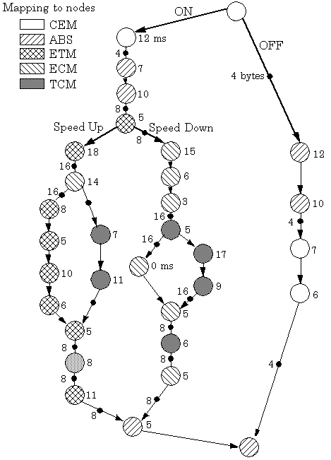
In Figure 4, we present the CC behaviour using a CPG. There are 32 processes in all. We have processes mapping to nodes in different shadows. The thick lines represent the conditional edges. For different nodes, we can distinguish the processes that the nodes mapped from Figure 4, and know the types of the nodes from the definition above.
Figure 4. The cruise controller behavior

A process can be activated only if all its inputs have arrived, and when its execution finishes it transmits the information to its successors. The numbers on the right of the nodes represent the execution time of each process. And the solid circles on the edges represent the messages.

According to the CPG model, a process, which is not a conjunction process, can be activated only after all its inputs have arrived. A conjunction process can be activated after messages coming on one of the alternative paths have arrived. All processes issue their outputs when they terminate. If we consider the activation time of the source process as a reference, the activation time of the sink process is the delay of the system at a certain execution [4].

3.4 Petri nets

3.4.1 Background of Petri nets

C.A. Petri introduced Petri nets in 1962, which is a more universal factor-process model. Petri nets models are designed specifically for modeling systems with interacting concurrent components, consisting of two types of components: places and transitions, places represent factors, and transitions represent processes. Places usually represent the condition, data, and resources of the Petri nets. And transitions usually represent actions, behaviours and events of the system.

Petri nets are “marked graphs”, edges connect places and transitions, and only from-transition-to-place or from-place-to-transition links are allowed. Tokens are used to mark the nodes. Each place can have a finite number of tokens. If each of the input places has at least one token, a transition is enabled. Transitions can be “fired” if all connected places contain tokens, one token is taken from each input place and one token is put into each output place, thus an enabled transition can fire.

Thus a Petri net is a way to graphically represent co-operating, concurrent, or to complete processes of the systems, in particular when communication, resource sharing or synchronization is important.

Formally defined, a Petri net is a 4-tuple, C= (P, T, I, O) where:

P = {p1, p2,p3,…, pn} n>=O is a finite set of places.
T = {t1, t2,t3,… tm} m>=O is a finite set of transitions.
P_{i} is an input place of transition tj if P_{i} ∈I(tj)
P_{i} is an output place of transition tj if P_{i} ∈O(tj)

So, A Petri net is bipartite graph which P∩T=∅ and also it is a directed graph [1].

3.4.2 Petri nets Example

Here we give a small example of a Petri net. See Figure 5.

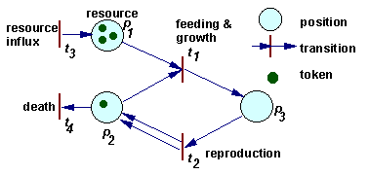
Figure 5. Example of a Petri nets
In Figure 5, the circles are called places (positions). The small rectangles are called transitions. The arrows are called edges, including input edges and output edges.
As we said above, the dynamics of a Petri net is a sequence of transition "firing". We can describe the whole process in Figure 5.
After a transition is fired, first, tokens are taken away from places, which have arrows going from these places to the transition considered. If more than 1 arrow goes from place to transition, then the number of tokens removed from that place is equal to the number of arrows. Second, new tokens are placed on places indicated by arrows that originate from the transition. The number of tokens placed corresponds again to the number of arrows (in the case of multiple arrows).
When transition t₁ is fired, then 1 token is removed from place p₁, 1 token is removed from place p₂, and 1 token is added on place p₃. When transition t₂ is fired, then 1 token is removed from place p₃, and 1 token is added on place p₂. Transition t₁ can be interpreted as feeding and growth, and transition t₂ as reproduction [2].

3.5 Others

Graphs play an important role in many different computer usages. A few graph examples are flow charts, state machines, entity relationship diagrams, call trees, and inheritance hierarchies and so on. In embedded systems design, general graph, CPG and Petri nets assisted as the design models, are commonly used graph represents. Similar examples could be drawn from a wide variety of other domains. There would be more and more new graph examples later introduced into embedded systems.

3.6 A Cruise Controller Example in XML

Specification is a precise description of the system. Based on the specification we have graph files that are processed by the application to display the specification model in a visual way. Here we give a specification example Behavioral_Model.XML in Appendix A, about the cruise controller, and it describes the components and how they interconnect in Figure 4.

Given this example, the application knows all the information about the nodes, the edges (arcs), and the connections, together with the properties on both the nodes and edges by reading respectively the elements <PROCESS>, <ARC>, attributes <Src> and <Dest>, and attribute <WCET> <Memory> <Delay> and so on.

The application is implemented to transform the graph file into the CPG model and present it visually. This XML description example simply shows the main construction of a concrete model on CPG.

4 Related Work

4.1 Graph drawing/editing tools

The design of a graph editor can be very concrete in its object-orientation. It is a challenge to design a good graph editor with powerful and adoptable functionality. Having a good graph-editing framework would save a lot of people a lot of work and would make much better effects in graph design.
There already exist a lot of graph drawing/editing tools. They have functionality in editing some certain types of graphs. Here we give two examples as visual graph editors: GEF (Graph Editing Framework) and JGraph.
Both GEF and JGraph use a model-view-controller (MVC) design method. It means that the framework could be split into three parts: model, view and control.

The model part describes the underlying graph model interface, and selection model, and the elements that they contain; as well as the classes used to change the graph model.

The view part studies the display’s internal representation of the graph, and the mapping and update between the model and the view. Special focus is given to the geometric pattern and context of graphs.

The control part explains the rendering process; the steps involved in in-place editing and cell handling, and the objects involved in data transfer.

4.2 Description in GEF and JGraph
4.2.1 GEF
Here is the demo implementations of GEF in Figure 6.
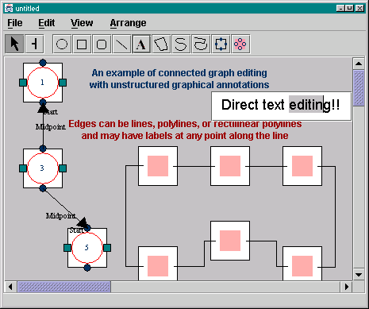

Figure 6. Example demo of GEF

GEF is a java class library that supports the construction of graph editing applications, which can draw and edit structured and unstructured diagrams. The goal of GEF project is to build a connected-graph-editing library that can be used to construct many, high-quality graph editing applications. It is a simple and concrete design for most graph application with a node-port-graph model.
GEF allows direct manipulation editing. The basic GEF functionality is something like Visio, which gives a core functionality ability to drag-and-drop diagram objects onto the diagram and then creates links between them. Each category of diagram has a separate set of components. But furthermore, GEF allows support connected graph editing. Right now it can read and write PGML (Precision Graphics Mark-up Language) files, but later it might be updated to use SVG (Scalable Vector Graphics) instead.

To be concrete, the editor coordinates the activity of the objects and passes the events to modes for interpretation. It provides the interface for the users to edit the connected graph in a visual way, such as add, delete or modify a node or edge, draw a diagram, realize multiple views on graphs and allow separation of concerns. The interface is in standard look-and-feel as much as possible, as we can see in Figure 6.

Although GEF is a powerful tool in function of editing the graph, it still has some limitations in design, in the library there are already 100 classes, it seems to be too many classes that make it harder to understand the whole construction of the system, and there is no enough demos, although a lot of new features have been added to GEF but few of them are shown in the demos. GEF needs new demos that test and demonstrate its new features. So it is important and good to existing demos.

There are also some bugs in the library, for example: FigEdgeRectilinear does not draw properly. There are missing cases to the logic that decides how to draw the arc, and FigEdgeRectilinear should move when both their end points move at the same time, but when we place two nodes, connect the nodes, select all objects, move the nodes all around, we can see that some points on the arc stay without moved. Another example limitation is about the ModePopup that displays a popup menu on Figs, for this menu is not customized to the particular Fig [16].

4.2.2 JGraph
Here is a simple example of JGraph in Figure 7.
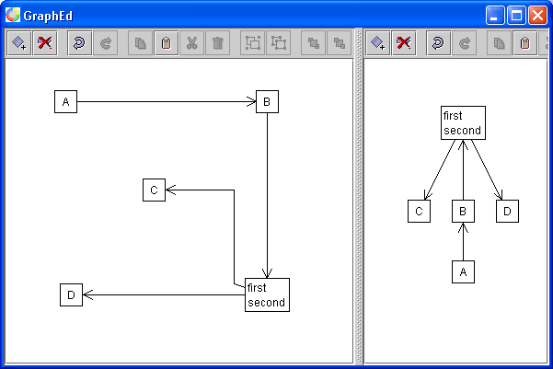

Figure 7. An example of JGraph: Multi-view version of Graph Editor

JGraph is a free component for graph visualization that brings the latest Java technology to any Swing user interface. With JGraph, users are able to display and edit complex information without the need to understand the underlying complexity. JGraph can be integrated into custom applications and websites, to use and interact with any data model, from XML files to databases or other native systems. JGraph is small and supports drag and drop and all the selection modes and display/editing options for editing the graph. It also provides a user interface in editing the graph; it is similar to GEF in way of node-port-edge design. But the obvious difference is that the ports, which bind to the nodes, are floating ports. The existing implementation of in-place editing and rendering was modified to work with views and history. The implementation of JGraph presents function in layering, grouping, and stepping-into groups for managing large diagrams.
It is easy to deploy JGraph since it’s based on Swing standards and we can display objects and relations (networks) in any Swing UI. JGraph can also be used on the server-side, for example to read a GXL (Graph eXchange Language) graph, apply a custom layout algorithm, and return the result as an SVG image.
We can see the concrete functionality of JGraph from Table 1, which lists the main editing operations for graphs.
Operations | Functionalities
Edge Editing | Add/Remove/Edit Points; Connect, Disconnect; Labels
Moving/Sizing | Transaction-Based, with Live-Preview
Selection | Single-Cell and Rubber-band Selection
Zoom | Arbitrary Zoom; Uses Java2D
Layering | View-Dependent Inter- and Intracell Layering
Grouping | Children Selectable; Uses Tree-Interface
Grid | Customizable Size, Color, Appearance
In-Place Editing | Direct Text Editing for all Cells
View Attributes | Separate Attributes for each attached View
Graph Layout | Easy Integration of Custom Algorithms
Ports | Floating Connection Points for Vertices
Handles | Flexible Interface for Cell-Modifications
Drag and Drop | Between JGraphs, JVMs and other applications/OS
Clipboard | Supports Multiple Transfer Formats
Command History | Multi-View; for all available Operations
Look-and-Feel | All Swing Pluggable Look-and-Feels
Routing | Customizable Routing with Default Algorithms
Visibility | Hide edges, vertices and groups
Clustering | Folding/Unfolding of Groups into Vertices
Table 1. Main features of JGraph
In implementation, the layering, grouping, handles, cloning, zoom, ports and grid are new features, which are standards-compliant with respect to architecture, and coding conventions. They are not used everywhere in Swing, and require new classes and methods.

Also JGraph has some bugs. In category of view, when using groups that contain both cells and ports, the edges attached to these ports are not properly updated. In control part, the set of changed cells returned by the SelectionChangeEvent does not reflect parents and children when stepping into groups is enabled. The event should also return (de) selected parents and children. And sometimes when remove all graph’s cells we might get null-pointer exceptions [15].

4.3 Graph libraries for GEF and JGraph
4.3.1 GEF library
GEF is a JAVA class library and it has seven packages:
uci.gef includes the classes JGraph, Editor, Fig, Selection, Layer, Guide, Mode, Cmd, NetPrimitive. It is the biggest and central package of GEF and includes most primary classes in GEF.
Editor does no work itself; it just coordinates the other objects. Despite this design, Editor is still the largest and most complex class. It acts as a shell and it mainly passes events and messages to supporting objects from other classes, but it does not handle input events, redraw the screen, determine what item the user clicked on, or modify the diagram data structure itself.

Cmds performs the actions in Editor. They define a doIt() method Ideally, an action should be used for any modification or command that the user might want to undo, include in a macro, or get help about.

Modes are modes of operation for the Editor. They interpret user input and instantiate Actions. So far there are mainly short-term modes for selection, modification, and creation of new objects. For example, when you drag an object around the Editor is in Mode Modify, but when you release the mouse button the Editor returns to Mode Select.

Guide constrains user mouse coordinates to help make an organized looking diagram. It helps the user make clean looking diagrams by constraining mouse coordinates. For example, Guide Grid implements grid snap.

Figs (short for Figures) contain a lot of draw-able objects that can be shown and manipulated in the Editor. They are basic drawing elements such as lines, rectangles and circles. Fig Group is the class for groups of Figs.

Layers contain the objects to be drawn. It serves as both display lists, and picks lists. As in many high ends drawing packages, Layers serve to group Figs into transparent overlays, manage redraw order and find the objects under a given mouse point.

Selections are objects used by the Editor when the user selects a Fig. They indicate the target of the next Action. Selections are responsible for drawing handles and handling dragging on handles.

NetPrimitive is the parent class of all Nodes, Ports, and Arcs.
uci.gef.event is classes that implement GraphSelectionEvents. By using PropertyChangeEvents, GEF can operate on many events but only define one new kind of event.
uci.gef.demo is classes that demonstrate how to use GEF to build applications and applets.
uci.graph provides interfaces and default classes for representing connected graphs. We can implement a GraphModel to access the application-specific objects to represent connected graphs.
uci.ui gives user interface code that is used by GEF, includes the Toolbar.
uci.util is utility classes that are used by GEF, includes preloading classes, a progress bar window, predicate objects, and some data structures.
uci.beans.editors are JavaBeans style property editors and associated classes for the property sheet. Currently editors are defined for Colors and Rectangles.
GEF library provides lots of functionality, and could be extended via sub classing. It is scalable [16].

4.3.2 JGraph library

JGraph library is created by 100% pure Java and integrates well into the Swing component class hierarchy because it is based on the Swing MVC pattern. The following are the main packages in JGraph library. All classes in JGraph have their equivalents in Swing, and all features are fully standards-compliant.
com.jgraph is JGraph's topmost package which contains the JGraph class. Class JGraph is a control that displays a network of related objects of a graph. A JGraph object doesn't actually contain your data; it simply provides a view of the data. Like any non-trivial Swing component, the graph gets data by querying its data model.
com.jgraph.event contains event classes and listener interfaces that are used to react to events fired by JGraph. It has two main classes: GraphModelEvent, which encapsulates information describing changes to a graph model, and is used to notify graph model listeners of the change, and GraphSelectionEvent, which provides an event that characterizes a change in the current selection.
com.jgraph.graph defines a number of classes and interfaces and provides support classes which include the graph model, graph cells, graph cell editors, drivers, controllers, and renderers.
com.jgraph.plaf contains the GraphUI class which extends the Swing ComponentUI class.
com.jgraph.plaf.basic contains the BasicGraphUI, which is GraphUI's default implementation.
Figure 8. presents the MVC architecture of JGraph library in UML and Figure 9 points to the meaning of each UML component.

Figure 8. JGraph MVC

Figure 9. UML for static structure diagrams
JGraph displays its data by drawing individual elements. Each element displayed by the graph contains exactly one item of data, which is called a cell. A cell may either be a vertex or an edge. Vertices may have neighbors or not, and edges may have source and target vertices or not, depending on whether they are connected [15].

5 A Prototype Implementation of a CPG Editor

5.1 Introduction and the description of the application
To design a graph editor, from the user's point of view, all graph manipulation is done inside the graph window in the graph editor, and from a technical point of view, the editor has some independent process with different responsibilities. The graph editor should have its graph data structure. It maintains and manipulates the graph depending on menu events and sends updates to the graph structure for visualization after each operation.
Based on this principle, our objective here is to produce an editor tool that supports the creation and editing of a special kind of graph called CPG. With the editor, the user is able to create new different types of nodes and edges, edit on existing nodes and edges and save the changes.
See Table 2 for the CPG shapes and subjects. There are mainly three node types: normal node, disjunction node and conjunction node, and there are three node shape types respectively represents three kinds of nodes in above order: circle, triangle and inverse triangle, which contain the nodes’ names, resources and the worst execution times labeled in the graphic shapes. CPG nodes are connected by edges. We have two kinds of edges: normal edges and conditional edges, whose ends are respectively represented by simple arrows and classic arrows.
CPG subjects | Shapes
Normal node
Conjunction node
Disconjunction node
Normal edge
Conditional edge
Table 2. Figures for CPG nodes and edges
Here in Figure 10 we show the user interface of the CPG editor. There are mainly three parts as usual editors in the window: menu, toolbar and graph panel. Menu “File” is designed to contain items New, Open, Close, Save, Save as, Page Setup, Print Preview, Print and Exit; Menu “Editor” contains items Undo, Redo, Cut, Copy, Paste and Select All; Menu “View” contains items Options Zoom in and Zoom out; Menu “Insert” contains items Process, Conditional process and Conjunction process; and “Help” contains item About. The above commands are common almost in any graph editor, except that there are especially three ones designed to insert the nodes of CPG. In tool bar we provide buttons as short cuts of the commands that almost cover all the menu items.

After opening the certain graph file, an instance of CPG is created in the graph panel and user can edit on it by moving, adding, deleting the cells, and then save it again as the graph file. I mainly implement the basic function in edit as modify the cells’ attributes on names, resources and worst execution times and so on.

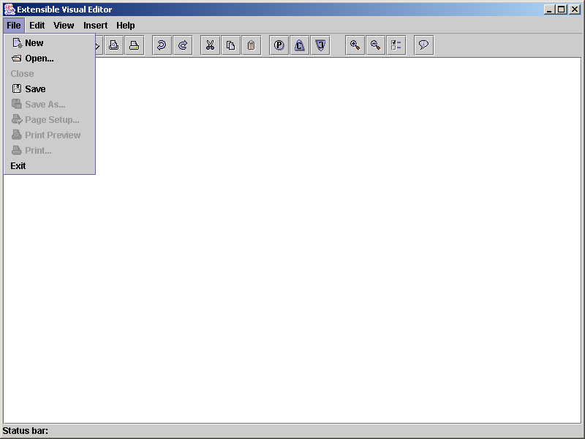

Figure 10. User Interface of the CPG Editor

This CPG editor we design operates on the graph file with the suffix name .cpg. Currently to simply the application, we write it in textual format. It of course can be written in formal XML language. The .cpg graph file records all the attributes of the graph cells. For nodes it includes node type, name, x coordinate axis position, y coordinate axis position, worst execution time, resource (the process that the node maps) and condition. For edges it includes edge type, name, name of source node, name of destination node, worst execution time, bus and condition.

Here it is an example of graph file named example.cpg. Each item of the attributes is separate by a blank space as defined.

example.cpg

disjunction_node N1 100 20 10 P2 C
node N2 20 120 5 P2 null
node N3 180 120 10 P2 null
node N4 180 200 2 P1 null
conjunction_node N5 100 260 3 P1 null
conditional_edge ARC1 N1 N2 2 B1 C
conditional_edge ARC2 N1 N3 1 B1 -C
edge ARC3 N2 N5 2 B1 null
edge ARC4 N3 N4 5 B1 null
edge ARC5 N4 N5 0 B1 null

When selecting the certain .cpg file and being ready to display the CPG model, the application has already read the CPG specification defined before and knows the graphic definition about the CPG cells and their interactive relations. Thus depending on the specification model, .cpg file is read and the information about all the elements is parsed to create the visual cells in a graphic way, and the CPG model instance is draw in the editor.

Figure 11 shows the open dialog, in which we can select CPG file such as example.cpg, to be displayed in the editor pane.

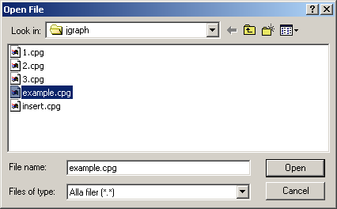

Figure 11. Open Dialog in CPG Editor

Figure 12 presents the window after the CPG model is drawed in the editor panel, given the attributes definition of the graph elements from the specification and the concrete information from the CPG file that the user selects to be edited.

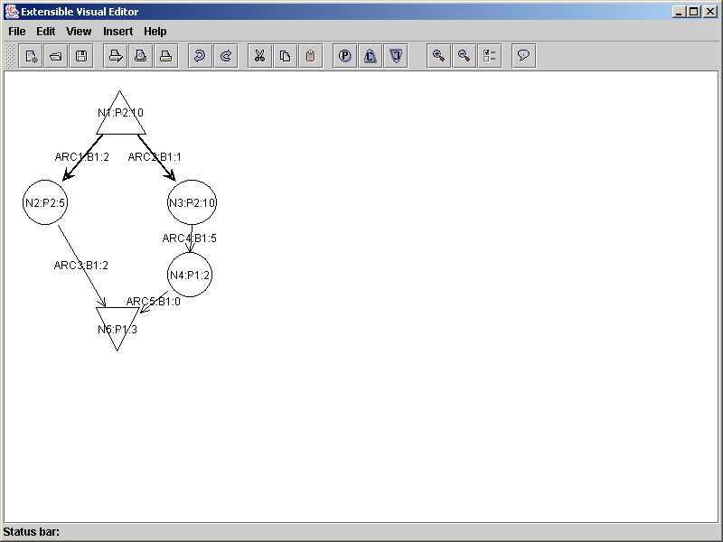

Figure 12. Display a CPG Model

The editor has three menu commands and buttons to add three respective types of nodes as showed in Figure 13, and because there are only two types of edges in CPG, it is easier to create the edges by drag-and-drop the mouse from source node to destination node. We have set the constraints about the connection that the edges from a disjunction node are always conditional edges in the application. Through the way in distinguishing the type of the source node, different types of edges are created automatically.

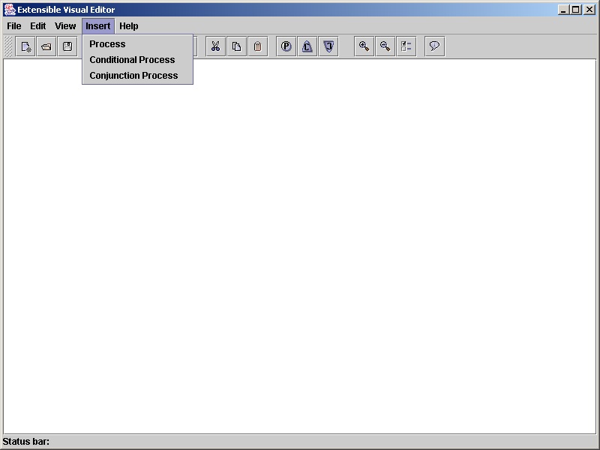

Figure 13. Commands to insert the new node

In Figure 14, we create a new CPG by adding new nodes in the graph panel and connecting them. Cells’ names, resources and execution time are currently default values that could be modified later by user. The data of the new CPG is still hold by the graph model structure, we need to save it into .cpg file in consistency. This is done in Figure 15. We save the new CPG into new.cpg file.

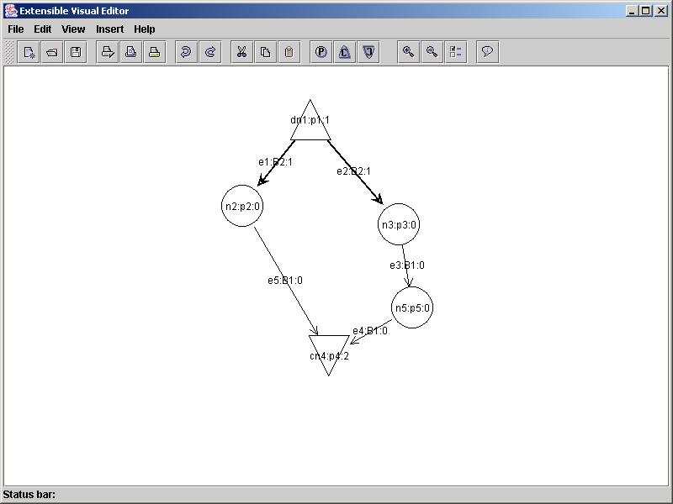

Figure 14. Create a new CPG

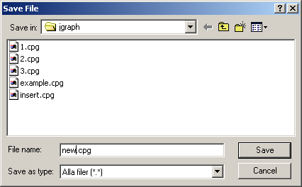

Figure 15. Save the new CPG

And the following is the new.cpg file that we created.

new.cpg

node n5 460 262 0 p5 null
disjunction_node dn1 339 38 1 p1 C
conjunction_node cn4 361 319 2 p4 -C
node n3 444 163 0 p3 null
node n2 258 141 0 p2 null
conditional_edge e1 dn1 n2 1 B2 C
conditional_edge e2 dn1 n3 1 B2 C
edge e3 n3 n5 0 B1 null
edge e4 n5 cn4 0 B1 null
edge e5 n2 cn4 0 B1 null

We can change the names, execution times, and resources of the cells by putting the mouse in the selected cell and double-clicking the mouse, to get the text field and input the new attributes, then finish it with key-pressed in “enter”. Cells can also be moved, cut, pasted and copied, but currently we didn’t implement the save function for changes in cut and, copy and paste. It will be the future work to improve the CPG editor.

For example, in Figure 16 we changed some cells’ attributes, and replace it with the original new.cpg file in Figure 17 and Figure 18.

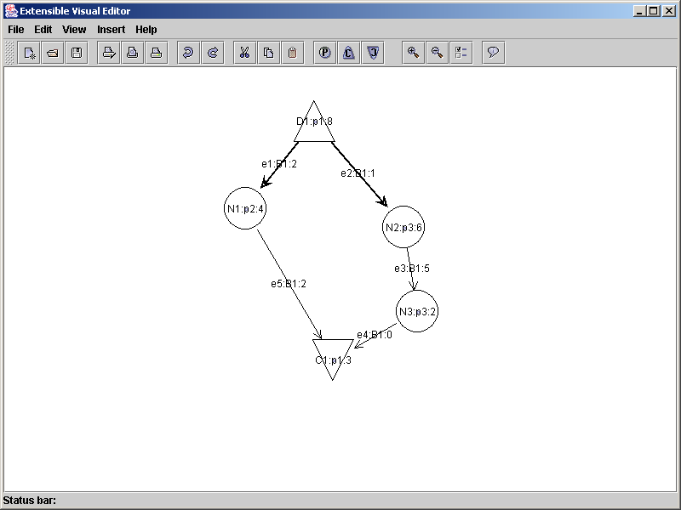

Figure 16. The new CPG after being edited
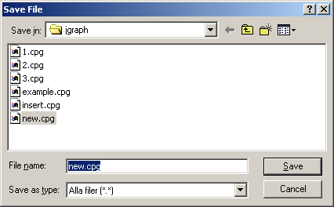

Figure 17. Save the edited new CPG

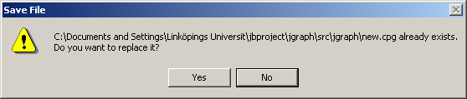

Figure 18. Replace the new.cpg

Here we can see the new.cpg file after modification, and compare to the original new.cpg file, obviously some information have been changed and saved.

new.cpg (after being edited)

node N3 460 262 2 p3 null
disjunction_node D1 339 38 8 p1 C
conjunction_node C1 361 319 3 p1 -C
node N2 444 163 6 p3 null
node N1 258 141 4 p2 null
conditional_edge e1 D1 N1 2 B1 C
conditional_edge e2 D1 N2 1 B1 C
edge e3 N2 N3 5 B1 null
edge e4 N3 C1 0 B1 null
edge e5 N1 C1 2 B1 null

5.2 Design

5.2.1 UML diagram

5.2.2 Using JGraph with MVC Design Method
The CPG editor is developed on JGraph project and JGrpahPad. We import these three JAR files from the project: jgraph-2.1-java 1.4/jgraph.jar (now the new version turns to jgraph 2.2.2), jgraph-1.0.6-java1.4/jgraph.jar and jgraphpad-2.0.0/jgraphpad.jar (now the new version is jgraphpad 2.2.2.1) [20], as the required libraries. And we can have the basis classes to extend our own Java files, seen from JGraph v2.2.2 API Specification [19].

Referenced on JGraph, CPG editor uses MVC (Model-View-Control) design method, that is to say, the framework of the editor could be split into three parts: model, view and control.

The model part provided by class CPGModel, describes the underlying CPG model interface, and selection model cpgModel, and three types of nodes together with two types of edges that cpgModel contain.

The view part provided by class CPGView, studies the display’s internal representation of CPG, and the mapping and update between the cpgModel and the cpgView.

The control part provided by the CPG user interface, explains the rendering process for different cells; the steps involved in in-place editing of the CPG and cell handling, and the objects involved in data transfer.
CPGModel is extended from DefaultGraphModel, and it gives the implementation of a CPG model, which in this editor is called cpgModel. cpgModel creates respectively EllipseCell for normal node, TriangleCell for the disjunction node and InverseTriangleCell for the conjunction node. All of them are extended from DefaultGraphCell and they provide an implementation of GraphCell interface. GraphCell defines the requirements for objects that appear as CPG Cells.
CPGView displays the objects in a CPG. The CPGView object doesn't actually contain the data; it simply provides a view of the data. The CPG gets data by querying its data model, an object of CPGModel. CPGView displays the data by drawing individual cells of CPG. Method CreateVertexView draws the nodes, including EllipseView for the normal node, TriangleView for the disjunction node and InverseTriangleView for the conjunction node corresponding with cpgModel. These three view classes are extended from VertexView. Method CreateEdgeView draws the edges. Both VertexView and EdgeView implement interface CellView, which defines the requirements for an object that represents a view for a CPG model cell.
Note in order to connect a pair of nodes successfully, and the edges are created on the ports that bind with the nodes. In this CPG editor we simply use the floating port in JGraph and import the classes PortView to draw the port and DefaultPort to create the port in CPG model.

5.3 Implementation

5.3.1 Implementation in Java

Application CPG editor has been created and run on Borland JBuilder Personal 7.0.155.0. The code was developed on Java 2 Runtime Environment, Java 2 Platform Standard Edition (J2SE) 1.4.0. [21]

5.3.2 Process in Design and Implementation

Here we give short explanation in implementation of the CPG editor.

We create two classes CPGNode and CPGEdge to respectively contain all the attributes of the cells. To open a new CPG, cell information recorded inside CPG graph are taken out, new objects of CPGNode are created and put into a hashtable named nodes, and new objects of CPGEdge are created and put into a linkedlist named edges. We can set the relationship between the node name and the source node name of the edge in the connection, thus in the hashtable nodes, the key is the node name and the value is the node itself.

There are the instructions to go through both the hashtable nodes and the linkedlist edges, through cpgView the application create the view of graph cells and the connections between them, and then paint them in the graph pane. Thus it finishes opening a CPG. This is done by method openGraph() in CPGModel.

Then we can do the edits on the CPG graph by running the methods inside the CPGModel, such as change the attributes, add a normal node, add a disjunction node and conjunction node, and find the ports and connect any pair of them. Here we have the constraints about the different types of the nodes. Every connecting edge, which starts from the disjunction node, the edge should be conditional edge and presented with a classic arrow at the end.

Inverse with the open process, to save a CPG model into CPG file, since the model holds all the cells together with their attributes, there is method saveGraph writing out all the attributes in order into a CPG file. Meanwhile, if the cell that the method dealing with is a node, and then it is updated into the hashtable nodes, otherwise, it’s updated into the linkedlist edges. Thus no matter the user add new cells, or modify the existed cells, the two structures that store the nodes and edges respectively will get the information synchronously with the cpgModel in order to create and update the CPG file, and maintain the system consistency.

6 Towards an Extensible Visual Editor

6.1 Similarities and Differences of Graph Editors

A graph editor is an interactive tool that presents a graph to the user pictorially and allows the user to edit the graph. Many graph-editing tools only have simple visualizations of models. They can display and edit the certain type of graph, but when the new type of the graph is introduced, the users might have to search for another suitable design graph tool, or finally there is no good one. To design a visual graph editor in powerfully extensible functionality could be a challenge but also a necessity.

Thus we now design an extensile editor for a series of graphs and when the new ones are introduced, we can just easily extend from the extensible editor based on the similarities in specifications. An extensible graph editor can be adapted easily to many different types of graphs.

For the visual graph editor, the software architecture basically consists of an application for creating, viewing, editing, and saving the various types of graphs that commonly used as the models in embedded systems. These functions should be necessary for all kinds of editors.

The specification model for each type of graph is needed when the application starts. It is usually in XML format and it mainly describes the graph model including nodes, edges and their properties. This specification could be considered as the definition of how the graph is presented. For a certain type of graph there should always be a specification model defined.

Despites the specification model, the editor should also be able to load graphs represented as formal graph files defined inside the application. The same type of graphs shares the same specification model definition file but each graph has their own graph file that gives the concrete information how it will be displayed. For example, the Behavioral_Model.xml file in Ch.3.6 and the example.cpg file in Ch.5.1, the difference between them is that the former is written in formal language and the latter is in textual format.

After the editor reading the graph file, the user interface is on the whole the same, but there would be different tool bars and menus loaded depending on different types of graph. Since variant graphs share the similarities in the basic structure that is constitutes with nodes and edges, the common edit operations like move, cut, paste, copy, delete, zoom in, zoom out and so on are in the same way, and the command items mostly differ in the operations related graph cells such as add new node and edge. For general graph there’s only simple node and simple edge but for CPG and Petri nets there would be several kinds of nodes and edges, thus affects the different set up in the menu and tool bar.

Each type of graph editor shares some similar methods but just different in some details according to the cell properties. No matter which type of graph that the extensible visual editor handles, the data is always hold in the model and is transferred among parts of model-view-control, although the data type and property is distinct.

6.2 Design Ideas

6.2.1 General Graph Editor

The general graph editor is used to display general graph structures and allows editing the graph. General graph model could be set to design normal interactive process graph, data flow, state diagram and so on.

There are mainly three parts of the editor: menu bar, tool bar and the graph pane. Since it only edits the general graph, basically there are only operations concerning with the normal nodes and edges and the general commands as adding, deleting, moving and so on.
The tool bar consists of a number of command buttons, which determine how the mouse interacts with the general graph to implement the editing. See Figure 19, It gives a demo interface for a general graph editor after loading the file.
Figure 19. General graph editor

In tool bar we have the command buttons, but some of them are common ones that being provided also in many graph editors, so we don’t need to describe their functionalities here in details. These basic buttons include: Select, New, Open (the graphs are loaded in way of specification files), Save (in format of specifications), Print, Cut, Copy, Paste, Delete, Undo, Redo, Text, Zoom, Help and so on. Of course we can improve the toolbar by finding new practical function.

In menu bar, we could have such File, Edit, Arrange, Diagram, View, Sets, Display, Option, Window and Help as the menus for instance. Of course with the concrete design goals we can always change and adjust the proper menu in order that we could close to the optimal design.

For general graph editor, there should be some commands especially on the graph elements.

Add a Node

A node is an endpoint in a graph. For general graph there is only simple node. Click the button of the node and use the mouse to position the node on the workspace. You will put the node on the pane until you release the mouse button. You need to press the button again to add more nodes. Each node contains a text field that is used for entering the information of the node such as name or short description as if the user double-clicks the node.

Add a Directed Edge

An edge represents a relationship between the nodes. We connect nodes with edges. The principle in connection is that the node has been defined binding with the port, which can be connected by the edges as both inputs and outputs. For general graph there are two types of edges, one is simple line without the arrow, which represents the undirected edge, and the other one is the line with an arrow in the end, which represents the directed edge. There is no special significance to the direction of the edges, but often they are used to indicate a hierarchical relationship.

Before you choose the type of edge you are going to draw, at least there should be a couple of nodes in the panel. Click the button labeled "Edge". Press and hold the left mouse button inside the node that you want to be the first endpoint. Drag the line outside this node and route it to the node you want as the other endpoint. After releasing the mouse, an edge is drawn, also with a text field that you can enter the attributes if you stop the mouse in the edge and double-click it.

Note if the edge is directed, then the arrow is showed at the end of the line when we drag to the endpoint, that is to say, you should know which node is the source node and which one is the destination node, and make the edge direction correct.

Add an Undirected Edge

To draw a simple edge without direction, you don’t care about which node is the start point and which one is the end, and just simply connect the two nodes by dragging mouse. The way is almost the same with above.

As to the edges in the graph, we should discuss whether self-looping edges are supported or not. If supported, we might need to add one more command button.

To delete a graph element, for the edge, we simply select it and use the command “delete”, and the pair of the nodes that are connected by the deleted edge remain unmodified, but for the node, any edge which are connected with this node should also be deleted together automatically, preventing the case that the edge cannot find the source and the target. “Cut” is similar with “delete”, and other commands, like “copy” and “paste”, are all operate on the selected objects in the panel.

6.2.2 CPG

In CPG editor, we simply define three kinds of nodes: normal nodes, conjunction nodes and disjunction nodes, the communication nodes and dummy nodes are also included in normal nodes, and two kinds of edges: normal edge and conditional edge, thus to insert the node, we have different operations, and we give three respective command buttons.

Since there are constraints with the nodes and edges in CPG, for instance, there is no self-connected for all nodes, and the alternative edges start from the disjunction node should meet in conjunction node. These constraints should be considered when we create the specification and design the editor. If we use wrong connections, there would generate a warning dialog.

The nodes and edges both have their text fields which user could enter the short information such as names and resources. We will give more details later in the implementation prototype for CPG editor.

Despites the more types of the graph elements and their constraints, the basic function and operation are similar with the general graph editor. Presented in Figure 20, we can arrange the toolbar like this showing the differences with the general graph editor, the main difference with general graph editor is that it provides richer toolbars and menu items specially for CPG editing.
Figure 20. Editor with the CPG

6.2.3 Petri nets graph editor

We may implement a modern editor to allow the user to create and modify a Petri nets model in a friendly and intuitive interactive environment. A Petri nets editor written in Java allows them to edit and symbolically execute their Petri nets design of their machine controller's intended behavior. Some of the editor's many features include: selection and manipulation of groups and individual Petri nets elements, a toolbar for frequently used operations and the ability to import and export the net as a formal file, to dynamic loading and saving of analysis modules----which can be user implemented XML file format.

The editor for Petri nets allows the user to enter Petri nets through a graphical interface. For the editor, the emphasis is on the internal representation of Petri nets. There are two parts in the editor, first we have at the top the different menus and tools the editor provides, second we have in the lower part net specific pane. In the pane, the user can add to and remove from the net, which they are editing.
We add operations especially for Petri nets editor like:

Add a Place
Use this tool to add a new place into the panel. Just click in where you want to put the place. Since the place may have the attributes like name, tokens number, value, and description, we could create a small editor dialog instead of a simple text field when double-click in the place, which gives more fields to enter and modify these properties.

Add a Transition
Use this tool to add a new transition into the Petri nets.

Add an arc
Use this tool to add a new arc into the Petri nets connecting the places and the transitions.

Add a token
Use this tool to add a new token into a place.

In Figure 21 we give a demo interface after the extensible editor loads a Petri net being edited.
Figure 21. Editor with the Petri nets graph

6.3 Software structure of the editor

Software architecture of the editor forms the backbone for building successful extensible graph editor. It largely permits or precludes the editor’s quality attributes such as performance or reliability. It represents a capitalized investment, an abstract reusable specification model of the graph that can be transferred and reused.

In Figure 22, we present the software architecture of the extensible graph editor by way of UML diagram.
Figure 22. Software Architecture

In system architecture, there are essentially the following main function parts (classes) that constitute the core of the extensible graph editor: GraphEditor, GraphView, GraphModel, together with the stored graph specification model definitions and graph files, form the extensible graph editor application.
GraphEditor:
This class provides an editor for manipulating graphical documents and displays the graph so that it may be edited. The editor is the central class of the extensible graph-editing framework, but it does not contain very much code. It can be small because all the models, graphical objects, editor modes, editor commands, and frames are implemented in their own classes.
At the start of the application, the GraphEditor reads the specification models that are defined respectively for variant type of graph and remembers which specification model is supposed to be use after getting the command from the user of opening one certain type of graph. Then the behavior of the GraphEditor is determined according to what graphs are selected. When the user selects one type of graph file from the disk to open, or in inverse way, try to save the graph model into this type of graph file, the GraphEditor acts as a shell for executing Commands that turn to the specification to get the definition properties of graph model. Thus each graph file defines the graph type at first. .
The GraphEditor is also a shell that dispatches control to various other objects that do the actual drawing and processing of input events.

GraphView:
Class GraphView is a control that displays the related graph objects using the specification of a graph. It allows interactive editing and serves as a simple front-end to class GraphEditor, and other classes which do the real work. A GraphView object simply provides a view of the graph data. The graph gets data by querying its GraphModel.
GraphView displays its data by drawing individual graph cells. Based on the graph specification, the GraphView Object knows the exact relationship between the type of graph node together with its property and the graph. For example, to editor a CPG, when meeting a disjunctional node, the CPG specification tells the GraphView to draw the node in shape of Triangle and the data type for execution time is int and for name it is string, ect.
GraphModel:

GraphModel defines an implementation for suitable data model of the graph and gives the widget access to the application data. It stores the data and allows the use of any application object as a node, port, or edge. This makes it much easier to add visualization to the application. The methods defined inside the GraphModel provide the access to the graph structure. The graph structure follows the graph specification, that edges have a source and target, and nodes have a set of connected edges including the data type of these graph cells.
??????????????
We extend the default GraphModel into CPGgraphModel, GeneralGraphModel and PetrinetsGraphModel. When loading different types of graphs, the concerned GraphModel works as a special graph model meeting the requirements of an extensible graph editor.
Cells:
This one contains all the graph cells’ information about the Graph, including Nodes, Edges, Ports, and the connecting properties between nodes. For instance, we have the fields about name, position for the nodes and name, source, target for the edge. GraphModel uses all the objects from this class.
??????????????
Since now the editor we design is an extensible one, so the Cells can be extended by subclasses to create new objects especially for CPG and Petri nets, for example, CPGCells that has ConjunctionNode, DisconjunctionNode, ConditionalEdge and so on. In Petri nets, which the cases might be PetrinetsCells, we can create new object for place, transitions and etc.

Of course in the application there is a part contains all the events (mouse movement, button clicks and key presses). The editor serves as a command shell for executing action. All event objects should be added to menus and toolbars. Also for an extensible graph editor, we should have different subclasses, in order that we can have various events to set different tool bars and menu bars for certain types of the graphs.

About the import methods, it should be responsible for reading the specification files and for saving the current graph to a graph file. To open a graph, it parses the specification information and calls the function to display the graph accordingly. The graph is saved as the graph file too. All information about the graph shall be stored in the graph file satisfying with the specification descriptions. The editor shall provide error handling for cases where open and save operations are unsuccessful.

The application shall provide memory resident data structure, graph data and object, to hold the current graph, which shall be used by the other function areas. It initiates the data constructor either by getting loading function to read in the specification of an existing graph, or by generating a new empty graph for the user to edit.

6.4 Specifying the Graph Models

6.4.1 Modeling graph types

We provide each graph type a specification, in this thesis in XML format, as a definition model to create the graph cells and to describe the attributes. In the XML specification, first we tell the graph type in the header part:

<GraphType>
…
</GraphType>

When the program parse the XML specifications and read the graph types, they can get the information about the graph property and later use them when to open a graph file having this specified type. For a certain type, the specification defines the certain respective cells and lists their properties and values. In details, we have nodes, edges needed to specify.

6.4.2 Specifying the graph elements

Node

Node part in graph specification could be defined like this:

<Node type="node_type1" image xlink:href =”directory of the node image”>
<Property name = “property1” type =property1_type …(other attributes for property1)>
<Property name = “property2” type =property2_type …>
…
<Property name = “propertyN” type =propertyN_type … >
</Node>

Different graph has different types of nodes, “node_type1” gives the type name of the node, and the image links to the figure that is stored in the disk or web and that is designed for this type of node.

A certain type of graph might have its special properties for node, and generally, there would be node’s name with string as its data type, and name’s attribute----position in center and color in black; node’s resource which might be a process with also string as its data type, the position on the right and color in blue, ect.

The specification should contain all kinds of nodes in a certain type of graph, and list all their attributes.

Edge

Edge part in graph specification could be defined like this:

<Edge type="edge_type" image xlink:href =”directory of the edge image”
sourceNode = “node_type1” destinationNode = “node_type2”>
<Property name = “property1” type =property1_type …(other attributes for property1)>
<Property name = “property2” type =property2_type …>
…
<Property name = “propertyN” type =propertyN_type … >
</Edge>

It is similar with the definition for node, but one important attribute for edge is its specification for the source node and the destination node, in order to create the correct connection.

A certain type of graph might have its special properties for edge. Generally, there would be edge’s name with string as its data type, and name’s attribute----position also in center; edge’s resource which is a bus with also string as its data type, ect.

Actually, the definition in source node and destination node of a type of edge gives the connection constraints somehow.

For more details in the specifications of each type of graph, we will discuss it next given the examples.

6.4.3 XML specification files for the graph types

Following the basic principles we set above to create the specification files, we separately give three XML specification examples for general graph, CPG and Petri net. Thus to build an extensible visual editor, these three specifications could be the models to create the corresponding graphs. And if there’s new type of graph being introduced, the specification model could just follow the design rules and be created in a similar way.

General Graph:

We give a simple example about the specification model created for general graph.

<?xml version="1.0" encoding="ISO-8859-1" ?>
<!-- Specification for General Graph -->
<General Graph>

<Node type="simple node" image xlink:href =”directory of the node image”>
<Property name = “name” type = “string” position = “center” color = “black”>
<Property name = “resource” type =”string” position = “right” color = “black”>
</Node>

<Edge type = "directed edge" image xlink:href =”directory of the image” sourceNode = “simple node” destinationNode = “simple node”>
<Property name = “name” type = “string” position = “center” color = “black”>
<Property name = “resource” type =”string” position = “right” color = “black”>
</Edge>

<Edge type = "indirected edge" image xlink:href =”directory of the image” sourceNode = “simple node” destinationNode = “simple node”>
<Property name = “name” type = “string” position = “center” color = “black”>
<Property name = “resource” type =”string” position = “right” color = “black”>
</Edge>

</General Graph>

In the specification, we specify one type of node and two types of edges based on the definition of a general graph. We might have other properties due to the concrete design requirements for a general graph editor, then everything should be put in a similar way.

CPG:

We give a simple example about the specification model created for CPG.

<?xml version="1.0" encoding="ISO-8859-1" ?>
<!-- Specification for CPG-->
<CPG>

<Node type="simple node" image xlink:href =”directory of the node image”>
<Property name = “name” type = “string” position = “center” color = “black”>
<Property name = “process” type =”string” position = “right” color = “black”>
<Property name = “wect” type = “int” position = “right” color = “black”>
<Property name = “condition” type = “string” value = “null”>
</Node>

<Node type="disjunction node" image xlink:href =”directory of the node image”>
<Property name = “name” type = “string” position = “center” color = “black”>
<Property name = “process” type =”string” position = “right” color = “black”>
<Property name = “wect” type = “int” position = “right” color = “black”>
<Property name = “condition” type = “string” value = “C”>
</Node>

<Node type="conjunction node" image xlink:href =”directory of the node image”>
<Property name = “name” type = “string” position = “center” color = “black”>
<Property name = “process” type =”string” position = “right” color = “black”>
<Property name = “wect” type = “int” position = “right” color = “black”>
<Property name = “condition” type = “string” value = “null”>
</Node>

<Edge type = "simple edge" image xlink:href =”directory of the image” sourceNode = “any type except for disjunction node” destinationNode = “anytype”>
<Property name = “name” type = “string” position = “center” color = “black”>
<Property name = “resource” type =”string” position = “right” color = “black”>
<Property name = “wect” type = “int” position = “right” color = “black”>
<Property name = “condition” type =”string” value = “null”>
</Edge>

<Edge type = "conditional edge" image xlink:href =”directory of the image” sourceNode = “disjunction node” destinationNode = “anytype”>
<Property name = “name” type = “string” position = “center” color = “black”>
<Property name = “resource” type =”string” position = “right” color = “black”>
<Property name = “wect” type = “int” position = “right” color = “black”>
<Property name = “condition” type =”string” value = “C”>
</Edge>

</CPG>

In the specification, we specify three types of node and two types of edges based on the definition of a CPG. Each type of node and edge both has more properties than that in general graph: wect means the worst execution time of the process the node mapped. For disjunction node, there is a condition and valued it as C, otherwise we give it null value. The resource in node’s property means the process being mapped and in edge’s property means the bus. Edge also has the execution time and condition. Only conditional edge’s condition value is C.

Specially in CPG, disjunction node only consider conditional edge as its output, so we include this constraints inside the specification.

Petri nets:

We give a simple example about the specification model created for Petri nets.

<?xml version="1.0" encoding="ISO-8859-1" ?>
<!-- Specification for Petri nets-->
<Petri nets>

<Place type = “place” image xlink:href =”directory of the node image”>
<Property name = “name” type = “string” position = “center” color = “black”>
<Property name = “process” type =”string” position = “right” color = “black”>
<Property name = “ect” type = “int” position = “right” color = “black”>
</Place>

<Transition type = “transition” image xlink:href =”directory of the node image” >
<Property name = “name” type = “string” position = “center” color = “black”>
</Transition>

<Arc type="ptotArc" image xlink:href =”directory of the node image”
source = ”place” destination = “transition”>
<Property name = “name” type = “string” position = “center” color = “black”>
</Arc>

<Arc type="ttopArc" image xlink:href =”directory of the node image”
source = ”transition” destination = “place”>
<Property name = “name” type = “string” position = “center” color = “black”>
</Arc>

<Token type="token" image xlink:href =”directory of the node image” source = “place” destination = “place”>
<Property name = “name” type = “string” position = “center” color = “blue”>
</Token>

</Petri nets>

In the specification for Petri nets, we specify the basic elements: place, transition, arc and token and their relations. The place has the process and execution time as the properties. The arc starts either from a place to a transition or from a transition to a place so we set two types of it. The token is moved between places and this is also specified.

Conclusion & Future work

Implement the editor for normal graph, Petri nets and other types of graphs and develop the main functions and make the extensible visual editor a complete application. We can add more functionality such like providing a layout generator designed with different algorithms.

In future, we should design the extensible visual editor in more efficient way, like include more properties in details of the certain type of graph. For example, it is very necessary to set constrains in CPG that all alternative paths from a disjunction node should meet together to a conjunction node.

Complete and improve the specification models for different types of graph depending on the improved design for the extensible editor. It is needed to develop them as the complete and practical ones in real time editing.

References

- K. Jensen “Coloured Petri netss. Basic Concepts, Analysis Methods” (Vol. 1). Ed. Springer-Verlag.

- W. Reisig ”A Primer in Petri nets Design”. Ed. Springer-Verlag.

- Robin.J.Wilson “Introduction to Graph Theory”. Ed. Academic Press. INC.

- Paul Pop “Scheduling and Communication Synthesis for Distributed Real-Time Systems” .2000.

- Syed Zia Akbar Zaidi “Portable Automotive Electronic Models Using Standard XML Technologies”. 2002

- G.F. Marchioro, J.M. Daveau, T.B. Ismail A.A. Jerraya “Hardware/Software Codesign for Embedded Systems Transformational Partitioning for Codesign”. 1998

- H. Keopetz “Automotive Electronics-Present State and Future Propects”.

- Andreas Gerstlauer, Daniel D. Gajski “System-Level Abstraction Semantics”. 2002

- Petru Eles, Alex Doboli, Paul Pop, Zebo Peng “Scheduling with Bus Access Optimization for Distributed Embedded Systems”. 2000

- Wayne H. Wolf “Hardware-Software Co-Design of Embedded Systems”. 1994

- Sun Microsystems, INC. “Web Services Made Easier----The Java APIs and Architectures for XML, A technical White Paper”. 2002

- Wayne Wolf. “Computers as Components, Principles of Embedded Computing System Design”. 2001
http://www.ee.princeton.edu/~wolf/embedded-book/overheads/

- EE-298 2. “Modeling of Embedded System Behavior”. 2000.3

- Layout information: http://www.yworks.de/en/products_yed_about.htm

- Docs for JGraph, http://jgraph.sourceforge.net/

- Docs for GEF, http://jgraph.sourceforge.net/

- Mohammad Reza Dawoudi.Specification and Design of Embedded System. www.physics.utu.fi/ett/kurssi/xG612/2001/lect02a.pdf

- Petru Eles, Krzysztof Kuchcinski, Zebo Peng, “Scheduling of Condtional Process Grapgs for the Synthesis of Embedded Systems”

- JGraph API Specification, http://jgraph.sourceforge.net/api/

- JGraph resources, http://jgraph.sourceforge.net/downloads.html

- J2SE, http://java.sun.com/j2se/

Appendix A

Behavioral_model.XML

<?xml version="1.0" standalone="yes"?>
<!DOCTYPE BEHAVIOURAL_MODEL[
<!ELEMENT BEHAVIOURAL_MODEL (PROCESS+, ARC+)>

<!ELEMENT PROCESS (WCET, Memory,
Sensor*, Actuator*)>
<!ATTLIST PROCESS Name CDATA #REQUIRED
Id CDATA #REQUIRED>
<!ELEMENT WCET (#PCDATA)>
<!ATTLIST WCET unit CDATA #REQUIRED>
<!ELEMENT Memory (#PCDATA)>
<!ATTLIST Memory unit CDATA #REQUIRED>
<!ELEMENT Sensor (#PCDATA)>
<!ELEMENT Actuator (#PCDATA)>

<!ELEMENT ARC (Src, Dest, Delay)>
<!ATTLIST ARC Name CDATA #REQUIRED
Id CDATA #REQUIRED>
<!ELEMENT Src (#PCDATA)>
<!ELEMENT Dest (#PCDATA)>
<!ELEMENT Delay (#PCDATA)>
<!ATTLIST Delay unit CDATA #REQUIRED>
]>

<BEHAVIOURAL_MODEL>
<PROCESS Name="PR1" Id="PR1">
<WCET unit="ms">0</WCET>
<Memory unit="KB">1</Memory>
<Sensor>Driver</Sensor>
<Sensor>Cruise Controller</Sensor>
</PROCESS>

<PROCESS Name="PR2" Id="PR2">
<WCET unit="ms">12</WCET>
<Memory unit="KB">10</Memory>
</PROCESS>

<PROCESS Name="PR3" Id="PR3">
<WCET unit="ms">7</WCET>
<Memory unit="KB">2</Memory>
</PROCESS>

<PROCESS Name="PR4" Id="PR4">
<WCET unit="ms">10</WCET>
<Memory unit="KB">5</Memory>
</PROCESS>

<PROCESS Name="PR5" Id="PR5">
<WCET unit="ms">5</WCET>
<Memory unit="KB">10</Memory>
<Sensor>Speed</Sensor>
<Sensor>Acceleration</Sensor>
</PROCESS>

<PROCESS Name="PR6" Id="PR6">
<WCET unit="ms">18</WCET>
<Memory unit="KB">10</Memory>
</PROCESS>

<PROCESS Name="PR7" Id="PR7">
<WCET unit="ms">14</WCET>
<Memory unit="KB">7</Memory>
</PROCESS>

<PROCESS Name="PR8" Id="PR8">
<WCET unit="ms">8</WCET>
<Memory unit="KB">3</Memory>
</PROCESS>

<PROCESS Name="PR9" Id="PR9">
<WCET unit="ms">5</WCET>
<Memory unit="KB">2</Memory>
</PROCESS>

<PROCESS Name="PR10" Id="PR10">
<WCET unit="ms">10</WCET>
<Memory unit="KB">4</Memory>
</PROCESS>

<PROCESS Name="PR11" Id="PR11">
<WCET unit="ms">6</WCET>
<Memory unit="KB">2</Memory>
</PROCESS>

<PROCESS Name="PR12" Id="PR12">
<WCET unit="ms">7</WCET>
<Memory unit="KB">5</Memory>
</PROCESS>

<PROCESS Name="PR13" Id="PR13">
<WCET unit="ms">11</WCET>
<Memory unit="KB">5</Memory>
</PROCESS>

<PROCESS Name="PR14" Id="PR14">
<WCET unit="ms">5</WCET>
<Memory unit="KB">2</Memory>
</PROCESS>

<PROCESS Name="PR15" Id="PR15">
<WCET unit="ms">8</WCET>
<Memory unit="KB">5</Memory>
</PROCESS>

<PROCESS Name="PR16" Id="PR16">
<WCET unit="ms">11</WCET>
<Memory unit="KB">7</Memory>
</PROCESS>

<PROCESS Name="PR17" Id="PR17">
<WCET unit="ms">15</WCET>
<Memory unit="KB">8</Memory>
</PROCESS>

<PROCESS Name="PR18" Id="PR18">
<WCET unit="ms">6</WCET>
<Memory unit="KB">3</Memory>
</PROCESS>

<PROCESS Name="PR19" Id="PR19">
<WCET unit="ms">13</WCET>
<Memory unit="KB">2</Memory>
</PROCESS>

<PROCESS Name="PR20" Id="PR20">
<WCET unit="ms">5</WCET>
<Memory unit="KB">2</Memory>
</PROCESS>

<PROCESS Name="PR21" Id="PR21">
<WCET unit="ms">20</WCET>
<Memory unit="KB">2</Memory>
</PROCESS>

<PROCESS Name="PR22" Id="PR22">
<WCET unit="ms">17</WCET>
<Memory unit="KB">1</Memory>
</PROCESS>

<ROCESS Name="PR23" Id="PR23">
<WCET unit="ms">9</WCET>
<Memory unit="KB">7</Memory>
</PROCESS>

<PROCESS Name="PR24" Id="PR24">
<WCET unit="ms">5</WCET>
<Memory unit="KB">2</Memory>
</PROCESS>

<PROCESS Name="PR25" Id="PR25">
<WCET unit="ms">6</WCET>
<Memory unit="KB">3</Memory>
</PROCESS>

<PROCESS Name="PR26" Id="PR26">
<WCET unit="ms">5</WCET>
<Memory unit="KB">2</Memory>
</PROCESS>

<PROCESS Name="PR27" Id="PR27">
<WCET unit="ms">5</WCET>
<Memory unit="KB">2</Memory>
<Actuator>Speed</Actuator>
<Actuator>Acceleration</Actuator>
</PROCESS>

<PROCESS Name="PR28" Id="PR28">
<WCET unit="ms">12</WCET>
<Memory unit="KB">8</Memory>
</PROCESS>

<PROCESS Name="PR29" Id="PR29">
<WCET unit="ms">10</WCET>
<Memory unit="KB">7</Memory>
</PROCESS>

<PROCESS Name="PR30" Id="PR30">
<WCET unit="ms">7</WCET>
<Memory unit="KB">5</Memory>
</PROCESS>

<PROCESS Name="PR31" Id="PR31">
<WCET unit="ms">6</WCET>
<Memory unit="KB">4</Memory>
</PROCESS>

<PROCESS Name="PR32" Id="PR32">
<WCET unit="ms">0</WCET>
<Memory unit="KB">1</Memory>
<Actuator>Driver</Actuator>
<Actuator>Cruise Controller</Actuator>
</PROCESS>

<ARC Name="ARC1" Id="ARC1">
<Src>PR1</Src>
<Dest>PR2</Dest>
<Delay unit="ms">0</Delay>
</ARC>

<ARC Name="ARC2" Id="ARC2">
<Src>PR2</Src>
<Dest>PR3</Dest>
<Delay unit="ms">1</Delay>
</ARC>

<ARC Name="ARC3" Id="ARC3">
<Src>PR3</Src>
<Dest>PR4</Dest>
<Delay unit="ms">0</Delay>
</ARC>

<ARC Name="ARC4" Id="ARC4">
<Src>PR4</Src>
<Dest>PR5</Dest>
<Delay unit="ms">2</Delay>
</ARC>

<ARC Name="ARC5" Id="ARC5">
<Src>PR5</Src>
<Dest>PR6</Dest>
<Delay unit="ms">0</Delay>
</ARC>

<ARC Name="ARC6" Id="ARC6">
<Src>PR6</Src>
<Dest>PR7</Dest>
<Delay unit="ms">4</Delay>
</ARC>

<ARC Name="ARC7" Id="ARC7">
<Src>PR7</Src>
<Dest>PR8</Dest>
<Delay unit="ms">4</Delay>
</ARC>

<ARC Name="ARC8" Id="ARC8">
<Sc>PR8</Src>
<Dest>PR9</Dest>
<Delay unit="ms">0</Delay>
</ARC>

<ARC Name="ARC9" Id="ARC9">
<Src>PR9</Src>
<Dest>PR10</Dest>
<Delay unit="ms">0</Delay>
</ARC>

<ARC Name="ARC10" Id="ARC10">
<Src>PR10</Src>
<Dest>PR11</Dest>
<Delay unit="ms">0</Delay>
</ARC>

<ARC Name="ARC11" Id="ARC11">
<Src>PR11</Src>
<Dest>PR14</Dest>
<Delay unit="ms">0</Delay>
</ARC>

<ARC Name="ARC12" Id="ARC12">
<Src>PR7</Src>
<Dest>PR12</Dest>
<Delay unit="ms">0</Delay>
</ARC>

<ARC Name="ARC13" Id="ARC13">
<Src>PR12</Src>
<Dest>PR13</Dest>
<Delay unit="ms">0</Delay>
</ARC>

<ARC Name="ARC14" Id="ARC14">
<Src>PR13</Src>
<Dest>PR14</Dest>
<Delay unit="ms">2</Delay>
</ARC>

<ARC Name="ARC15" Id="ARC15">
<Src>PR14</Src>
<Dest>PR15</Dest>
<Delay unit="ms">2</Delay>
</ARC>

<ARC Name="ARC16" Id="ARC16">
<Src>PR15</Src>
<Dest>PR16</Dest>
<Delay unit="ms">2</Delay>
</ARC>

<ARC Name="ARC17" Id="ARC17">
<Src>PR16</Src>
<Dest>PR27</Dest>
<Delay unit="ms">0</Delay>
</ARC>

<ARC Name="ARC18" Id="ARC18">
<Src>PR5</Src>
<Dest>PR17</Dest>
<Delay unit="ms">2</Delay>
</ARC>

<ARC Name="ARC19" Id="ARC19">
<Src>PR17</Src>
<Dest>PR18</Dest>
<Delay unit="ms">0</Delay>
</ARC>

<ARC Name="ARC20" Id="ARC20">
<Src>PR18</Src>
<Dest>PR19</Dest>
<Delay unit="ms">0</Delay>
</ARC>

<ARC Name="ARC21" Id="ARC21">
<Src>PR19</Src>
<Dest>PR20</Dest>
<Delay unit="ms">4</Delay>
</ARC>

<ARC Name="ARC22" Id="ARC22">
<Src>PR20</Src>
<Dest>PR21</Dest>
<Delay unit="ms">4</Delay>
</ARC>

<ARC Name="ARC23" Id="ARC23">
<Src>PR21</Src>
<Dest>PR24</Dest>
<Delay unit="ms">0</Delay>
</ARC>

<ARC Name="ARC24" Id="ARC24">
<Src>PR20</Src>
<Dest>PR22</Dest>
<Delay unit="ms">0</Delay>
</ARC>

<ARC Name="ARC25" Id="ARC25">
<Src>PR22</Src>
<Dest>PR23</Dest>
<Delay unit="ms">0</Delay>
</ARC>

<ARC Name="ARC26" Id="ARC26">
<Src>PR23</Src>
<Dest>PR24</Dest>
<Delay unit="ms">4</Delay>
</ARC>

<ARC Name="ARC27" Id="ARC27">
<Src>PR24</Src>
<Dest>PR25</Dest>
<Delay unit="ms">2</Delay>
</ARC>

<ARC Name="ARC28" Id="ARC28">
<Src>PR25</Src>
<Dest>PR26</Dest>
<Delay unit="ms">2</Delay>
</ARC>

<ARC Name="ARC29" Id="ARC29">
<Src>PR26</Src>
<Dest>PR27</Dest>
<Delay unit="ms">2</Delay>
</ARC>

<ARC Name="ARC30" Id="ARC30">
<Src>PR27</Src>
<Dest>PR32</Dest>
<Delay unit="ms">0</Delay>
</ARC>

<ARC Name="ARC31" Id="ARC31">
<Src>PR1</Src>
<Dest>PR28</Dest>
<Delay unit="ms">1</Delay>
</ARC>

<ARC Name="ARC32" Id="ARC32">
<Src>PR28</Src>
<Dest>PR29</Dest>
<Delay unit="ms">0</Delay>
</ARC>

<ARC Name="ARC33" Id="ARC33">
<Src>PR29</Src>
<Dest>PR30</Dest>
<Delay unit="ms">1</Delay>
</ARC>

<ARC Name="ARC34" Id="ARC34">
<Src>PR30</Src>
<Dest>PR31</Dest>
<Delay unit="ms">0</Delay>
</ARC>

<ARC Name="ARC35" Id="ARC35">
<Src>PR31</Src>
<Dest>PR32</Dest>
<Delay unit="ms">1</Delay>
</ARC>

</BEHAVIOURAL_MODEL>

