Final Thesis
Integrating Embedded Systems Design Tools in the Generic Modeling Environment
by
Peter Tureby and Fredrik Wester
LITH-IDA-EX-ING—05/004--SE
2005-10-07

Supervisor: Sorin Manolache
Examiner: Paul Pop

Framläggningsdatum  2005-10-07  Publiceringsdatum (elektronisk version) |  | Institution och avdelning  Institutionen för datavetenskap  581 83 LINKÖPING | 

Språk  Svenska  X Engelska |  | Rapporttyp  Licentiatavhandling  X Examensarbete  C-uppsats  D-uppsats  Övrig rapport  __________________ |  | ISBN:
Språk  Svenska  X Engelska |  |  |  | ISRN: LITH-IDA-EX-ING—05/004--SE
Språk  Svenska  X Engelska |  |  |  | Serietitel
Språk  Svenska  X Engelska |  |  |  | Serienummer/ISSN
URL för elektronisk version
http://www.ep.liu.se/exjobb/ida/2005/dd-c/004/

Titel
Integrating Embedded Systems Design Tools in the Generic Modeling Environment

Författare
Peter Tureby, Fredrik Wester

Sammanfattning

Embedded systems are becoming increasingly complex, and they have to meet competing requirements such as performance, cost, low energy consumption and reliability. As the task of designing such systems becomes more difficult, new system-level design tools are needed to support the designer.

System-level embedded systems design tools help to automate design tasks such as mapping of functionality to processors, scheduling of functionality, analysis of performance and power consumption. Often, tools focused on a specific design task have to be integrated into a complex design flow, supported by a graphical user interface.

In this thesis, we propose a systematic way of integrating the system-level design tools developed in the Embedded Systems Laboratory (ESLAB) at Linköping University into the Generic Modeling Environment (GME). GME is a configurable toolkit for creating domain-specific modeling environments. We have developed meta-models for the embedded systems models used at ESLAB, together with their visual representation. We have proposed a systematic approach to the integration of existing ESLAB tools into GME. As a case study, we have shown how to integrate the “holistic scheduling tool” into GME.

Nyckelord

Embedded systems, visual environment, Generic Modeling Environment, modeling, meta-modeling, integration

Abstract

Embedded systems are becoming increasingly complex, and they have to meet competing requirements such as performance, cost, low energy consumption and reliability. As the task of designing such systems becomes more difficult, new system-level design tools are needed to support the designer.

System-level embedded systems design tools help to automate design tasks such as mapping of functionality to processors, scheduling of functionality, analysis of performance and power consumption. Often, tools focused on a specific design task have to be integrated into a complex design flow, supported by a graphical user interface.

In this thesis, we propose a systematic way of integrating the system-level design tools developed in the Embedded Systems Laboratory (ESLAB) at Linköping University into the Generic Modeling Environment (GME). GME is a configurable toolkit for creating domain-specific modeling environments. We have developed meta-models for the embedded systems models used at ESLAB, together with their visual representation. We have proposed a systematic approach to the integration of existing ESLAB tools into GME. As a case study, we have shown how to integrate the “holistic scheduling tool” into GME.

Table of Contents

1 Introduction 1
1.1 Embedded systems 2
1.1.1 Example area: automotive electronics 2
1.2 Embedded systems design 4
1.2.1 Design 4
1.2.2 Modeling 5
1.2.3 Meta-modeling 5
1.2.4 Analysis 6
2 Motivation 8
2.1 Analysis tools at ESLAB 8
2.1.1 The holistic tool 9
2.1.2 The hierarchical tool 10
3 Related work 14
3.1 SymTA/S 14
3.2 Aires 15
3.3 MAST 16
4 Modeling using GME 19
4.1 Generic Modeling Environment 19
4.2 Meta-modeling in GME 20
4.3 Simple process graph meta-model 21
4.3.1 Example 22
4.4 MAST meta-model 23
4.5 Model visualization 25
5 Tool integration in GME 27
5.1 Design and implementation choices 27
5.1.1 Communicating with the holistic analysis tool 27
5.1.2 Visualization of the analysis results 27
5.1.3 Development methodology 28
5.2 ESLAB’s tools integration 29
5.2.1 The GME interpreter 29
5.2.2 The holistic tool 30
5.3 Usage example 30
6 Conclusions and future work 34
6.1 Conclusions 34
6.2 Future work 34
References 35

Introduction

Embedded systems are becoming increasingly complex, and they have to meet competing requirements such as performance, cost, low energy consumption and reliability. As the task of designing such systems becomes more difficult, new system-level design tools are needed to support the designer.

System-level embedded systems design tools help to automate design tasks such as mapping of functionality to processors, scheduling of functionality, analysis of performance and power consumption. Often, tools focused on a specific design task have to be integrated into a complex design flow, supported by a graphical user interface.

The objective of this master thesis is to provide a systematic approach to the integration of the various system-level design tools developed at the Embedded Systems Laboratory (ESLAB), Linköping University, into a visual design environment.

Existing toolkits such as the Generic Modeling Environment (GME) provide an efficient approach to the development of domain-specific visual environments. The configuration of GME for the embedded systems domain is achieved through the use of meta-models, which specify the embedded systems models that can be used in the environment.

Thus, we have developed meta-models for the embedded systems models used at ESLAB, together with their visual representation. We have proposed a systematic approach to the integration of existing ESLAB tools into GME.

Chapter 1 gives an introduction to embedded systems and their design and analysis.

Chapter 2 introduces the “holistic” and “hierarchical” tools developed at ESLAB to analyze embedded systems.

Chapter 3 presents two visual environments: SymTA/S, a tool that allows analysis of complex embedded systems and System-on-Chip (SoC), and Aires, a tool for modeling and timing analysis integrated with the Generic Modeling Environment (GME). MAST, a set of open source tools for modeling and analysis of real-time systems, is also presented in this chapter.

Chapter 4 contains an introduction to GME and presents the two meta-models we have created in GME.

Chapter 5 covers the integration of ESLAB’s analysis tools in GME and the visual presentation of the analysis results.

Finally, chapter 6 contains our conclusions and some suggestions for future work.

Embedded systems
An embedded computer system is a computer system with tight coupling between software and hardware that is designed to perform a specific task. An embedded system is often part of a larger system in which it interacts with other embedded systems. A PC is not an embedded computer system, it’s a general purpose system. Embedded systems are everywhere – automobiles, planes, trains, space vehicles, machine tools, cameras, consumer and office appliances, cellphones, PDAs and other handhelds as well as robots and toys. More than 99% of the worldwide production of microprocessors is used in embedded systems [1].

Designing embedded computing applications is much more demanding than designing applications for PCs or workstations. Embedded computing systems not only have to provide sophisticated functionality, they often have to perform in real time. Other important factors are the need for sophisticated user interfaces, for example moving maps in GPS navigation systems, manufacturing costs and power consumption.

Example area: automotive electronics
The number and sophistication of electronic systems in vehicles has increased exponentially in the past four decades. In 1977, the average cost of electronic components in a car was $110. By 2001, it had increased to $1800 [2]. It is estimated that in 2006, the cost of electronics will amount to 25 percent of the total manufacturing cost. The field of automotive electronics is also where most automotive innovation takes place nowadays.

There are several reasons for the increase in the level of computer controlled functions onboard a car. The market has a constant demand for increased vehicle performance, more functionality, lower fuel consumption and less exhaust, and the car manufacturers need shorter time to market and lower development and manufacturing costs. Combined with the ever-increasing performance and cost-effectiveness of semiconductor technology, this has led to the rapid increase in the number of electronic systems in cars.

At the same time as the number of systems has increased, the type of functions they implement has evolved, from the first fuel injection systems in the 1960's to today's electronic implementation of highly critical functions such as steering or braking. With the complexity growing very quickly, and the constraints (in terms of performance and reliability, but also cost and time to market) getting tighter, it is becoming increasingly difficult to design such systems. New design techniques are needed to manage the complexity of embedded systems, shorten the time to market and reduce the costs of development and manufacturing [3].

Figure 1: Engine control unit

The engine controller (see Figure 1), which controls the mixture of air and fuel to optimize fuel consumption and exhaust levels, is a good example of a system with strict performance and reliability requirements. The timing constraints of the engine controller are mainly determined by the engine speed. For example, in an engine running at 6,000 RPM, the controller must recalculate the air to fuel ratio for each cylinder every 20 ms. If the engine has 4 cylinders, the entire loop must be completed in 5 ms [4]. Failing to meet the timing constraints leads to more emissions and lower fuel efficiency.

Embedded systems design
The aim of a design methodology is to coordinate the design tasks such that the time-to-market is minimized, the design constraints are satisfied, and various parameters are optimized. System-level design is illustrated in Figure 2.

Design
The design process can be divided into five major steps: system requirements, specification, architecture design, component design and system integration.

Figure 2: Major tasks in the design process

In the requirements stage one gathers an informal description from the customer. This will serve as the basis for creating the specification.

The specification is a more precise document that shows what will be included in the embedded system. It can be viewed as a contract between the customer and the developer. As such, it must be carefully written so that it captures the customer’s requirements in a way that can be clearly followed during design.

The architecture design is a plan for the overall structure of the system. It specifies what components will be needed to build the embedded system.

The component design effort builds the needed components in conformance to the architecture and specification. Some components such as CPUs, memory chips and so on are standard off-the-shelf components, other components the engineers will have to design and construct themselves. When building components it is important to ensure that the system runs properly and doesn’t use too much power or memory space.

System integration is the final part of the design process. This part consists of putting the entire system together and testing it. System integration is difficult because bugs are typically found during this phase, and the debugging facilities for embedded systems are usually much more limited than those available for desktop systems [1].

Modeling
A model is a description of a physical system that may be used to predict or explain the behavior of that system. There is a lot of research in the area of system modeling and specification, and an impressive number of models have been proposed.

The scheduling and mapping design tasks deal with sets of interacting processes. A process is a sequence of computations (corresponding to several building blocks in a programming language) which starts when all its inputs are available. When it is done executing, the process produces its output values. The tools at ESLAB use dataflow process networks (also called task graphs, or process graphs) to describe interacting processes, and have represented them using directed graphs, where a node is a process and the directed arcs are dependencies between processes.

Meta-modeling
In a broad sense, a meta-model is a model of a modeling language. In other words, for a model of an application represented by process graphs, the underlying meta-model defines what a process graph is. A meta-model is also a model, but it has two characteristics that set it apart from other models: it captures the essential features and properties of the system that is being modeled, and it is part of a meta-model architecture that allows a meta-model to be viewed as a model, which is itself described by another meta-model. This meta-model is sometimes called a meta-meta-model [5].

As a first step towards the creation of a visual environment for embedded systems design we have created a meta-model for process graphs (see section 4.3). This meta-model has been used as input to the GME toolkit. GME takes as input meta-models for a given domain, and creates a visual modeling environment for that domain. Thus, we have created a visual modeling environment for process graphs.

As a second step, we have extended the process graph meta-model to a more general model of embedded systems (see section 4.4).

Analysis
Given a model of an embedded system, analysis tools are used to verify various properties of the model. An important class of model properties are the timing properties, which are verified using timing analysis tools.

Kopetz [6] gives a definition for a real-time system as being “a computer system in which the correctness of the system behavior depends not only on the logical results of the computations, but also on the physical instant at which these results are produced.”

Timing constraints
Real-time systems have well-defined, fixed timing constraints called deadlines. Processing must be done within the deadlines, or the system will fail. Real-time systems can both be hard or soft depending on how important it is for the task to be completed on time. Hard real-time systems have to fulfill the timing constraints, otherwise catastrophic situations can occur. Soft real-time systems can tolerate a certain amount of delays without serious consequences, except a reduced “quality of service”.

The research at ESLAB addresses hard real-time systems that have to fulfill strict timing requirements.

Scheduling
The scheduling policy decides the order in which processes should execute. Scheduling policies can be preemptive or non-preemptive. There are two important aspects of the scheduling policy. First, upon receiving a request, the scheduling policy must decide whether to process the request immediately, or to postpone the execution. Secondly, the scheduling policy must also decide when an interrupted process should be allowed to continue.

Under non-preemptive scheduling, once the CPU has been allocated to a process, the process keeps the CPU until it releases the CPU either by terminating or by switching to a waiting state. Preemptive scheduling means that if a high-priority process is released during the execution of a lower priority process, there will be an immediate switch to the higher priority process. Static scheduling means that the scheduling decisions are computed off-line.

The most commonly used scheduling policy is fixed-priority scheduling (FPS). Each process has a fixed priority which is computed pre-runtime, and the order in which the processes are executed depends on their priority. With EDF (Earliest Deadline First) scheduling, the processes are executed in the order determined by their absolute deadlines. The next process to run is the one with the shortest deadline. The absolute deadlines are computed at run-time, and hence the scheme is described as dynamic.

Utilization-based schedulability analysis
Schedulability analysis is used to determine whether a process set is schedulable. We will take a closer look at utilization-based schedulability analysis and response time analysis for FPS and EDF.

Liu & Layland’s utilization-based test for FPS states that a process set with a combined utilization of less than 69.3% will always be schedulable. However, if the utilization is higher, the process set may still be schedulable; further analysis is required to determine whether it is. For EDF the test is much simpler: a process set is schedulable as long as the utilization is less than 100% [7].

The worst-case response time of a task is the length of the longest interval from a task’s release till its completion. Each task in a process set has its own execution time.

Worst-case response time analysis
Worst-case response time analysis is another method for determining whether a set of tasks is schedulable, but rather than looking at the total utilization, worst-case response time analysis is concerned with the response time of each individual task, i.e. a task is schedulable if its worst-case response time is less than or equal to its deadline. The worst-case response time of a task is the length of the longest interval from a task’s release until its completion. This analysis works well for FPS (assuming that all processes are independent) as the worst-case response time occurs when all processes are released at a critical instant (a critical instant occurs when all higher priority processes are ready to execute), and thus only the first release needs to be analyzed. With EDF, the worst-case response time for each process does not occur at the critical instant. Therefore, one must consider each release until the full process set repeats its execution [7].

The analysis tools developed at ESLAB use the worst-case response analysis approach to determine if the timing properties of the application are fulfilled.

Motivation

Analysis tools at ESLAB
The Embedded Systems Laboratory (ESLAB) at Linköping University performs research in all aspects of embedded systems design. Special emphasis is placed on the development of analysis tools for distributed embedded real-time systems. Two recent analysis tools developed at ESLAB are the “holistic” tool [8] and the “hierarchical” tool [9].

An analysis tool takes as input the embedded system specification given as a set of interacting processes, see Figure 3, and the system implementation. Each circle in Figure 3 represents a process. A process starts executing when all its inputs have arrived, and produces the outputs when it finishes. A link between two circles in Figure 3 is a data dependency between two processes. For each process, the worst-case execution time is known, and we know the size of each message exchanged between two processes. The timing constraints are also given, for example, as deadlines for processes. Figure 4 shows GME configured for the holistic tool (see section 2.1.1).

The system implementation consists of the hardware architecture, the mapping of processes to the processors in the architecture, and the selection of the scheduling policies to be used for the activation of processes. The hardware architecture is composed of several types of processors interconnected using different types of networks. Several scheduling policies can be used for processes, for example, static non-preemptive scheduling or fixed-priority preemptive scheduling.

Figure 3: Overview of the analysis tools

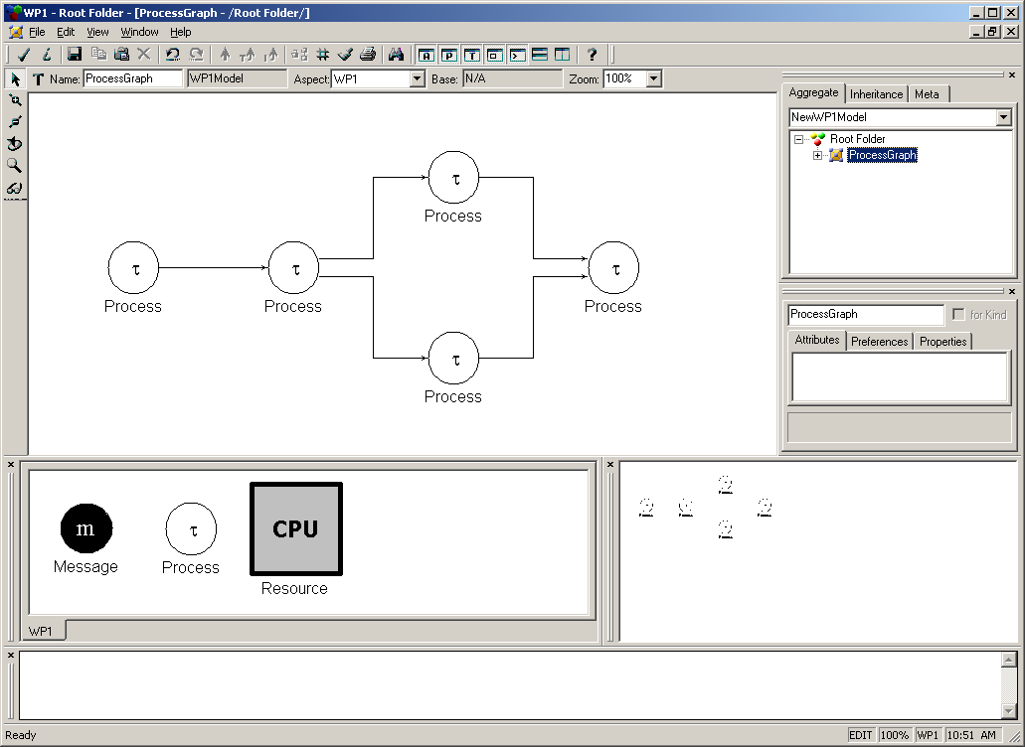
Figure 4: A process graph in GME

The analysis tools give the answer if the embedded system is schedulable or not. The type of analysis used in the tools at ESLAB is called “response time analysis”. The idea is to determine, for each process, its worst-case response time. That is, how long it takes to execute, in the worst case scenario, considering the interference from the other processes in the system. Then, the worst-case response time of each process is compared to its deadline, and if all the deadlines are satisfied, then the embedded system is schedulable.

The tools are command line tools that do not have a user interface, and take the input and produce the output as files. The next two sections present the tools for which we have developed a user interface using GME.

The holistic tool
The “holistic” tool performs a holistic response analysis. The analysis is called “holistic” because it looks at the system as a whole, when it performs the analysis. It can handle a distributed system where the application is distributed on several processors, and it can analyze the worst case scenarios very well, to exclude those scenarios that cannot happen, because it has a global (that is, holistic) view of the system.

The tool takes as input a text file describing the system to be analyzed as a set of interacting tasks as shown here:

{
task = 0;
graph = 0;
processor = 6;
period = 4000;
deadline = 3984;
priority = 1;
deterministic 1600;
}
(...)
{
task = 18;
graph = 6;
processor = 7;
period = 18000;
deadline = 5983;
priority = 2;
dependent
17 {
bus = 0;
priority = 0;
deadline = 0;
deterministic 360;
};
deterministic 3600;
}

The output of the holistic tool contains the worst-case response time and jitter for each task:

Task 00 1600.00 0.00
(...)
Task 18 19600.00 1600.00

The hierarchical tool
Research in the real-time and embedded systems communities shows that no scheduling policy is clearly superior to the others. For example, static cyclic non-preemptive scheduling has the advantage of predictability and testability, but it lacks the flexibility offered by approaches such as fixed priority preemptive scheduling.

That is why one has to choose the right scheduling approach depending on the particularities of the embedded application. This means not only that there is no single “best” approach to be used, but also that inside a certain application several scheduling approaches should be used together. When several scheduling policies share a resource, they can be organized in a hierarchy, where a higher level scheduler controls the activation of a lower level scheduler.

ESLAB has developed the “hierarchical” analysis tool to handle embedded systems where several scheduling policies are used, and are organized in a hierarchical fashion.

The input to the “hierarchical tool” is given as follows (the comments indicate the format of the input file):

/* p #number_of_processors
length_of_bus_cycle
start_ST_phase_1 end_ST_phase_1 start_DYN_phase_1 end_DYN_phase_1
...
start_ST_phase_p end_ST_phase_p start_DYN_phase_p end_DYN_phase_p
number_of_task_graphs */

5
100
0 10 10 10
10 20 20 20
20 30 30 30
30 40 40 40
40 50 50 100
4

/*
List of tasks and messages:
T_i N_i #period and number of activities in task graph i
C_ij Cb_ij proc_ij D_ij policy_ij priority_ij type_ij remapable repartitionable
successors_ij: succ_i1 ... succ_ik

where:
C_ij - WCET for the task/message j from the task graph i
Cb_ij - for the task/message j from the task graph i
proc_ij – processor where the task j is mapped/processor sending message j
D_ij - the deadline
policy_ij - the scheduling policy: CSS, FPS, EDF
priority_ij - priority
type_ij - 0=task, 1=message
remapable - 0=no, 1=yes
repartitionable - 0=no, 1=yes
successors_ij - number of successors in the task graph for task j
succ_i1..succ_ik- the index in the task graph I of activities which are direct succesors of task j
*/

460 7
12 0 1 460 0 5 0 1 1
1: 4
10 0 1 460 0 4 0 1 1
1: 5
7 0 0 460 0 3 0 1 1
1: 6
6 0 0 460 0 2 0 1 1
0:
0.5 0 1 460 0 5 1 1 1
1: 1
0.5 0 1 460 0 3 1 1 1
1: 2
0.5 0 0 460 0 2 1 1 1
1: 3
(...)
460 20
15 0 3 460 0 5 0 1 1
1: 10
6 0 3 460 0 4 0 1 1
1: 11
3 0 3 460 0 3 0 1 1
1: 12
5 0 4 460 0 2 0 1 1
2: 13 18
17 0 4 460 0 1 0 1 1
1: 14
9 0 4 460 0 5 0 1 1
1: 15
5 0 3 460 0 4 0 1 1
1: 16
6 0 4 460 0 3 0 1 1
1: 17
5 0 3 460 0 2 0 1 1
0:
20 0 3 460 0 1 0 1 1
1: 19
0.5 0 3 460 0 0 1 1 1
1: 1
0.5 0 3 460 0 0 1 1 1
1: 2
2 0 3 460 0 5 1 1 1
1: 3
0.5 0 4 460 0 4 1 1 1
1: 4
0.5 0 4 460 0 3 1 1 1
1: 5
2 0 4 460 0 2 1 1 1
1: 6
1 0 3 460 0 1 1 1 1
1: 7
1 0 4 460 0 0 1 1 1
1: 8
2 0 4 460 0 0 1 1 1
1: 9
0.5 0 3 460 0 0 1 1 1
1: 6

The tool is called as follows:

$ ttet RealLifeExample.ttet rle.out

The output of the tool contains the list of worst-case response times of each process and message.

Related work
There have been several efforts aimed at integrating existing analysis tools into visual environments. In this section we present the state-of-the-art approaches to the development of visual environments for embedded systems.

SymTA/S
SymTA/S (SYMbolic Timing Analysis for Systems) is a research project developed at the technical university of Braunschweig, Germany. From the SymTA/S whitepaper: “SymTA/S is a performance and analysis tool based on formal scheduling analysis techniques and symbolic simulation. The tool supports heterogeneous architectures, complex task dependencies, context aware analysis, and combines optimization algorithms with system sensitivity analysis for fast design space exploration” [10].

SymTA/S performs timing and performance analysis of complex, heterogeneous embedded systems [10].

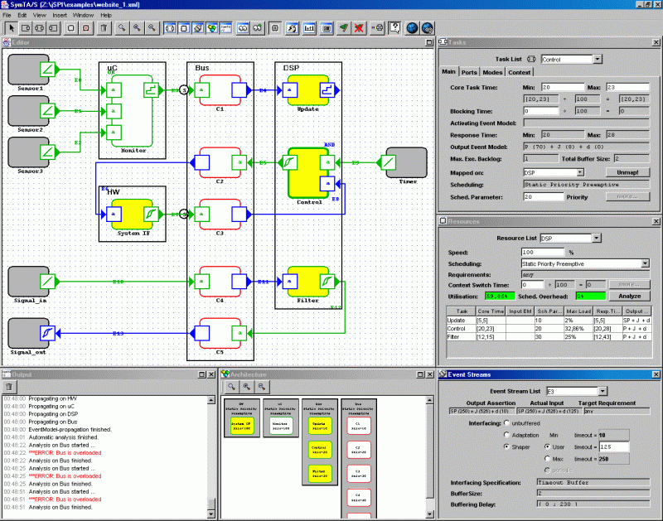
Figure 5: Screenshot of the SymTA/S GUI

Figure 5 shows a screenshot of the SymTA/S GUI. The large workspace with various colored boxes is the editor window, every square in this window is a task and the black frames are resources. There are a few dialogs on the right where the designer can define the properties of tasks, schedulers and so on, and at the bottom of the screen is the output window, which displays errors and status messages, and the architecture window which gives an overview of the system architecture.

SymTA/S is written in Java and as such comes in a JAR package. It is called as follows:
$ java -classpath algorithms;symtaS.jar org.spiproject.Application

Aires
Aires (Automatic Integration of Real-time Embedded Software) is a set of timing analysis and design view construction algorithms integrated in the Generic Modeling Environment (GME). It supports the analysis of non-functional properties, such as timing and schedulability, of embedded systems at different stages of the development process. Aires includes a meta-model – which allows modeling the hardware architecture, the software architecture and the runtime model – and various analysis algorithms. The model is exported as an XML file for sharing among different tools. The algorithms are implemented as plug-ins, and could also be integrated in other modeling environments [11]. The Aires tool has been implemented for avionics applications and automotive applications [12].

Figure 6: Screenshot of the Aires GUI

Figure 6 shows a screenshot of the Aires GUI. We have used a similar approach to the one in Aires, but we display the results graphically whereas Aires outputs textual results (except for the component-to-task mapping, which can be visualized graphically).

MAST
MAST (Modelling and Analysis Suite for Real-Time Applications) is an open source tool suite that enables modeling and timing analysis of real-time applications. It includes tools for worst-case response time analysis, priority assignment, blocking time and slack time calculation, and simulation. The MAST model can be used in a UML environment to design real-time applications.

MAST uses a very rich, event-driven model of the real time system. Complex dependencies can be established between different tasks; for example, tasks may be activated by the arrival of several events, or may generate several events upon completion. This makes it ideal for analyzing real-time systems designed using UML design tools, which have event-driven models of the system [13].

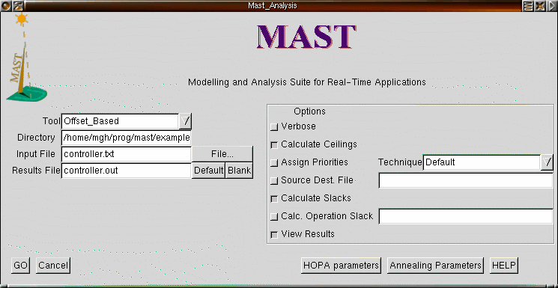
Figure 7: gmast, a graphical front-end for MAST
The MAST tools are command-line applications. There is a graphical front-end called gmast, a screenshot of which can be seen in Figure 7.

On the left hand side one chooses the analysis tool (in the screenshot, gmast is setup to use the Offset_Based tool), the directory and the input file to use. On the right hand side one can set some options, in this case ”Calculate Ceilings” is checked because they didn’t set the priority ceilings of the shared resources, so they have to be calculated by the tool.

Below is an excerpt of the input file, controller.txt.

Model (
Model_Name => Controller,
Model_Date => 2000-01-01);

-- File controller.txt

-- Processing Resources

Processing_Resource (
Type => Fixed_Priority_Processor,
Name => CPU_1,
Worst_Context_Switch => 0.25);
(...)
Transaction (
Type => Regular,
Name => Emergency,
External_Events => (
(Type => Sporadic,
Name => E4,
Min_Interarrival => 50)),
Internal_Events => (
(Type => regular,
name => O4,
Timing_Requirements => (
Type => Hard_Global_Deadline,
Deadline => 6,
Referenced_Event => E4))),
Event_Handlers => (
(Type => Activity,
Input_Event => E4,
Output_Event => O4,
Activity_Operation => Emergency,
Activity_Server => Emergency)));

The result file, controller.out, follows a similar format. There is also a graphical utility, gmastresults, for easier viewing of the results (see Figure 8).

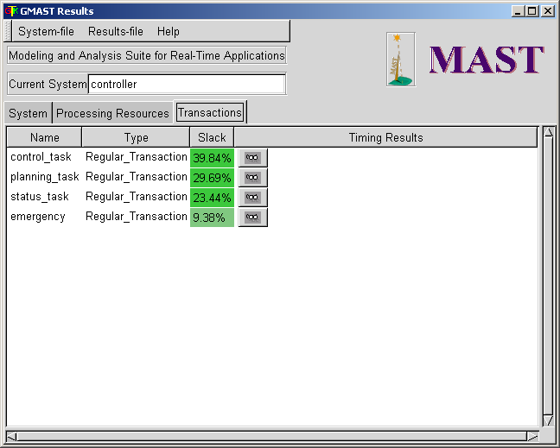
Figure 8: gmastresults, a utility for displaying analysis results

Similar to Aires, there is a visual environment called UML-MAST that is integrated with the Rational Rose UML modeling tool.

Modeling using GME
In this thesis, we propose a systematic way of integrating the system-level design tools developed in the Embedded Systems Laboratory (ESLAB) at Linköping University into the Generic Modeling Environment (GME).

The next section presents the Generic Modeling Environment, and the related concepts. Then, we show how a simple process graph model can be captured in GME using a meta-model. Finally, the complete meta-model of a realistic model of an embedded system is presented.

Generic Modeling Environment
The Generic Modeling Environment (GME) is a configurable toolkit for creating domain-specific environments for modeling, model analysis and program synthesis. The configuration is accomplished through meta-models (see section 1.2.3).

GME’s meta-modeling language is based on UML class diagrams and OCL constraints. The meta-models are used to automatically generate the target domain-specific environment, which can then be used to build domain models that are stored in either a model database or XML format.

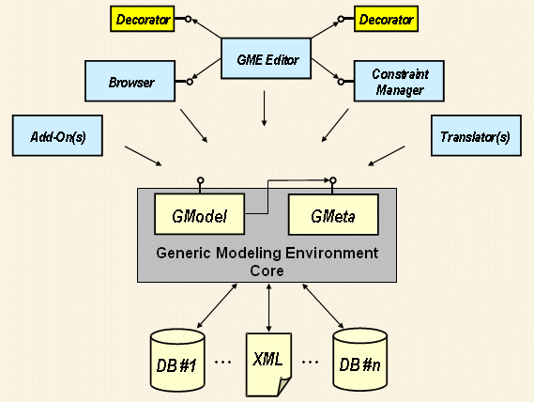
Figure 9: The architecture of GME [14]

Meta-modeling in GME

The modeling technique used in the GME meta-modeling environment is a subset of the Unified Modeling Language (UML) called UML Class Diagrams. A class diagram gives an overview of a system by showing the classes and their relationships. Figure 10 shows a simple UML class diagram that represents a movie theater.

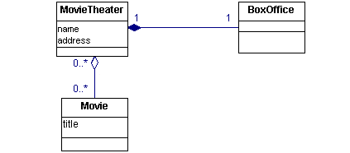
Figure 10: UML class diagram [15]

The class diagram consists of three classes: MovieTheater, BoxOffice and Movie. MovieTheater is the central class of the diagram, and BoxOffice and Movie are associated with it. A class is represented by a rectangle divided into three parts: name, attributes and operations. A BoxOffice belongs to only one MovieTheater. This is a composition association, indicated by a filled diamond in the diagram. The association between MovieTheater and Movie is an aggregation, in which one class belongs to a collection. Here, MovieTheater has a collection of Movies [15].

Another important association is generalization (i.e., inheritance) which indicates that one class is a superclass of another. It is denoted by a triangle pointing to the superclass.

The generic modeling concepts supported by GME are variations of the UML entities, relationships and attributes. Among other things, GME provides additional features that are supposed to guide and simplify the meta-modeling process. The core GME concepts are listed below [16].

- Atoms are the most basic type of entity. They have no internal structure; everything about an atom is contained in its name, its attributes and the relations in which it participates.
- Models are like atoms, but models have the ability to contain other objects, such as atoms or other models.
- Connections represent relationships between objects.

Some other important GME concepts are:

- Attributes are used to store information about an object. They can contain text, integers, real numbers or boolean values.
- Aspects represent different views of the structure of a model. A model with several aspects will display different subsets of its contained entities depending on the aspect selected.
- Constraints are validity rules applied to a model.
- Folders are used for organization of a modeling project, similar to directories in a file system.

Simple process graph meta-model
The first task of the thesis consisted of implementing a simple process graph meta-model (as described in Section 2.1) in GME. This model contains three entities: Process, Message and Resource. Processes can be connected to each other, either directly or through messages, to form a process graph. Resources can also be connected to each other, for example, several CPUs connected to a bus. All processes and messages are assumed to be scheduled using fixed priority preemptive scheduling.

The entities in the process graph meta-model, presented in Figure 11, have the following attributes:

Process
BCET: best case execution time, in milliseconds
WCET: worst case execution time, in milliseconds
Priority: process priority (bigger number = higher priority)
Period: how often the process is executed, in milliseconds
Jitter: the maximum variation in a process’s release time (optional)
Offset: release time relative to the start of the schedule (optional)
Deadline: the deadline of the process (optional)

Message
Size: the size of the message in bits

Resource doesn’t have any attributes.

The Connection objects define how the entities can be connected, and they are named according to the entities they connect:
- PtP defines dependencies directly between processes
- PtR maps a process onto a resource
- PtM and MtP define message passing between processes
- RtR connects resources to each other, i.e. a bus

Figure 11: Process graph meta-model

Example
A new meta-model is installed by selecting Register Paradigms from the File menu. Using the process graph meta-model, GME will create an environment for modeling process graphs (as presented in Figure 4). Using this environment, the designer can create and modify process graph models, as the model depicted in Figure 12.
Figure 12: A process graph example

This is a very simple process graph with two processes, P1 and P2, running on a single CPU, CPU0. The arrow from P1 to P2 denotes a data dependency (P2 takes as input the output of P1), and the arrows pointing from each process to the CPU simply state that the processes will run on that CPU. The model visualization is discussed in section 4.5.

MAST meta-model
ESLAB has several different analysis tools which handle different kinds of embedded systems. Expressing all these systems requires a more complex model than the simple process graph model presented in the previous section. The MAST model was chosen because it is, with few exceptions, sufficiently general and extensible to handle today’s analysis tools as well as tools that may be developed in the future.

Figure 13: MAST meta-model
The MAST model is divided into different categories:
Processing Resources are hardware components with some form of processing capacity, i.e. processors and networks.
System Timers represent the way the system handles timed events.
Network Drivers represent operations executed as a result of network activity.
Schedulers are system objects which implement scheduling policies. They can be structured in a hierarchy.
Scheduling Policies, such as Fixed Priority Scheduling or Earliest Deadline First, decide the order in which processes should execute.
Scheduling Parameters specify parameters for scheduling servers.
Synchronization Parameters specify parameters for access to shared resources.
Scheduling Servers represent schedulable entities (processes and messages) in a processing resource.
Shared Resources represent resources that are shared between different tasks.
Operations represent messages or processes.
Events activate instances of an activity or influences the behavior of an event handler.
Timing Requirements (i.e., deadlines) impose restrictions on when events may be generated.
Event Handlers represent actions, such as the execution of a task, that are activated by an event, and that generate an event as output.
Transactions are graphs of events and event handlers, which represent related tasks executed in the system, i.e., task graphs [17].

In the process of creating a meta-model in GME based on MAST, we have tried to follow the description of the MAST format [17] as closely as possible.

Some entities in the MAST model have attributes that refer to other entities. These are implemented as connections. If an attribute in the MAST model refers to either another entity or an identifier, as is the case with the Packet_Server attribute of the Packet_Driver, there is in our meta-model both a connection and an attribute.

The MAST model also defines a number of different attribute data types, whereas the meta-modeling environment of GME defines only a few simple types (boolean, enum, integer, floating point, string). For most MAST types this isn’t an issue because they are minor variations of these simple data types. The Date-Time type, however, uses the extended ISO8601 format with no time zone to represent dates and times (for example, 2005-10-14T22:51:31). Attributes of this type are represented by string attributes in our meta-model.

Model visualization
After interpreting and registering the meta-models, they can be used to create models. However, by default all the components are represented by grey rectangles. We can change that by assigning an icon to each component. This is done through the Attributes dialog from the ClassDiagram aspect. For each component that should have a custom icon (see Figure 14), type the filename of the image in the “Icon name” field. The bitmaps should be placed in a directory named “Icons” in the directory of the paradigm (meta-model).

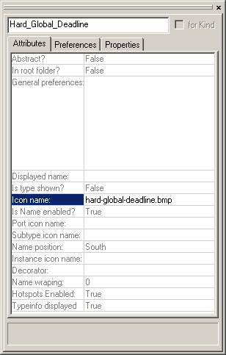
Figure 14: GME attributes dialog

Tool integration in GME
In this section we present the integration of the holistic tool, and some design choices that we have made.

Design and implementation choices

Communicating with the holistic analysis tool
We now have a meta-model in GME that can be used to create simple process graph models, and we need to be able to pass such models to the holistic analysis tool described in section 2.1.1, and also to read the results back into GME for presentation.

GME provides several ways to access its data from within other programs, the most popular technique being writing a GME interpreter. An interpreter is a component, usually a DLL, which is loaded and executed by GME upon the user’s request [16].

Writing an interpreter allows us to access all the data that the tool needs to perform its analysis, but how do we pass this data to the tool? We chose to let the interpreter store the data from the process graph model in a temporary file, and subsequently we modified the tool itself to load this temporary file and read the data into its internal data structures. This process is explained in more detail in section 5.2.

Visualization of the analysis results
After the analysis is complete the results should be presented graphically. The requirements on the presentation were:
- It should look similar to the processor utilization graph in SymTA/S;
- It should be possible to zoom in and out of the graph.

We considered the following approaches:
- Drawing the graph directly in GME;
- Writing an external application;
- Using a vector graphics format such as SVG.

We decided to use Scalable Vector Graphics (SVG) to draw the processor utilization graph. SVG is a language for describing two-dimensional graphics. The file format is based on XML and allows for describing images with vector graphic shapes, images and text. SVG is an open standard developed under the W3C Process [18].

Development methodology
Constructing software is a challenging task, essentially because software can be very complex. Therefore, it is important to have a good development methodology when constructing software. There are many kinds of development methods, but we will look at two of them, the waterfall model and the iterative model.

- The waterfall model
The waterfall model has dominated software development for nearly 40 years. This development method divides the development process into several steps (specification, design, implementation, testing being the major ones) which are carried out in sequence, one after the other, with little or no feedback between them [19]. Each stage produces a product which is the input into the next stage.

The advantage of the waterfall model is that dividing the development process into smaller steps makes it less complex and more manageable. The biggest drawback with strict waterfall programming is that you can’t go back to an earlier stage when you detect a problem, and problems are often found in a late stage of the development process, but in the real world, the waterfall approach is rarely applied in its strictest sense – some feedback will be allowed between the different stages.

- Iterative programming
Iterative, or incremental, programming is a development methodology based on values of simplicity, communication, feedback and sometimes courage. You start with a small program, make some small changes, compile and test. When it works, make another small change.

Making only small changes is likely to lead to fewer error messages which makes it much easier to track down errors. Another advantage is always having a running version of the program; if you run out of time, you can still deliver the last version, which at least does something. Having a running program is psychologically satisfying as well.

The disadvantage of iterative development is that it is tempting to start coding too early, leading to unstructured and inefficient programming. Many additional iterations may be needed [20].

For the programming part of this thesis we have used iterative programming. It works reasonably well for small projects (in our case, just over 500 lines of code).

ESLAB’s tools integration
As a case study, we have written a GME interpreter that allows the user to run a process graph model through the holistic tool (see section 2.1.1) and see the results by simply clicking a button.

The GME interpreter
GME comes with a set of tools that help with setting up a development project for the interpreter. More information about these tools and the Builder Object Network (the framework for which most GME components are built) can be found in lesson 3 of the GME tutorial [16].

The Builder Object Network (BON) instantiates C++ objects for each object (atoms, connections, models, etc.) in the GME model. These objects can be accessed through methods that act on them.

The interpreter essentially performs the following steps:
- Extracts information about all the processes in the model
This is best illustrated with a code example that shows how one would navigate the GME model tree:
vector<Process> processes;
const CBuilderFolderList *folds = builder.GetFolders();
POSITION fPos = folds->GetHeadPosition();
while(fPos)
{
CBuilderFolder *fold = folds->GetNext(fPos);
const CBuilderModelList *roots =
fold->GetRootModels();
POSITION rootPos = roots->GetHeadPosition();
while(rootPos)
ScanModels(roots->GetNext(rootPos), fold->GetName(), processes);
}
Those who are familiar with Microsoft Foundation Classes (MFC) will see that this is very similar to the way one navigates list structures in MFC [21].
- Writes the process information to an XML file
- Calls the holistic tool
Here we have to find the ID of the process that has been selected and pass it to the tool so that it knows for which process it should analyze the worst case scenario.
- Displays the processor utilization graph
The graph is stored in an SVG file, which is opened in the application registered as the default viewer for SVG files.
- Updates the GME model with the worst-case response time (WCRT) of each process
The tool outputs the WCRT which is read back into the interpreter and added to the model using a similar loop to the one used for extracting information.

The holistic tool
In order to make the integration with GME possible, we have made some additions to the holistic tool. The code we have written is found in two C++ source files:
- gme.cpp, which is based on main.c from the holistic tool.
- svg.cpp

XML parsing
The XML file that describes the application, model.xml, is structured like this:
<Model>
<Process>
<Attr1>value1</Attr1>
...
<AttrN>valueN</AttrN>
</Process>
<Process>
...
</Process>
</Model>
Our parser in gme.cpp is designed specifically for this structure.

Visualization
The worst-case scenario determined by the tool consists of a series of events. Each event gives the task, the job, the execution start time and the execution end time:

( 0, 0) 0.00 45.00
( 1, 0) 45.00 78.00
( 2, 0) 78.00 98.00

Based on this information and the process data from model.xml, an SVG file is created which visualizes the worst-case scenario.

Usage example
Here we give an example of the integration of the holistic tool. As shown in Figure 15, we have an application consisting of three processes on a single CPU, and we want to know the worst-case scenario of the process P3.

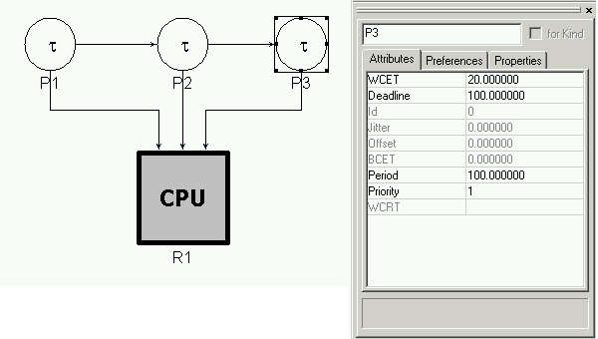
Figure 15: Process graph and attributes of the selected process
Upon starting the analysis (File -> Run Interpreter -> MGA.Interpreter.WorstCaseScenario), the interpreter creates an XML file describing the application:

<?xml version="1.0">
<Model>
<Process>
<Name>P1</Name>
<Id>100000002</Id>
<ResourceId>100000005</ResourceId>
<Priority>3</Priority>
<BCET>0</BCET>
<WCET>45</WCET>
<Deadline>100</Deadline>
<Jitter>0</Jitter>
<Offset>0</Offset>
<Period>100</Period>
<Connections></Connections>
</Process>
<Process>
<Name>P2</Name>
<Id>100000003</Id>
<ResourceId>100000005</ResourceId>
<Priority>2</Priority>
<BCET>0</BCET>
<WCET>33</WCET>
<Deadline>100</Deadline>
<Jitter>0</Jitter>
<Offset>0</Offset>
<Period>100</Period>
<Connections>100000002;</Connections>
</Process>
<Process>
<Name>P3</Name>
<Id>100000004</Id>
<ResourceId>100000005</ResourceId>
<Priority>1</Priority>
<BCET>0</BCET>
<WCET>20</WCET>
<Deadline>100</Deadline>
<Jitter>0</Jitter>
<Offset>0</Offset>
<Period>100</Period>
<Connections>100000003;</Connections>
</Process>
</Model>

Then the holistic tool is executed, which produces a processor utilization graph, as presented in Figure 16, as an SVG file and calls the SVG viewer.

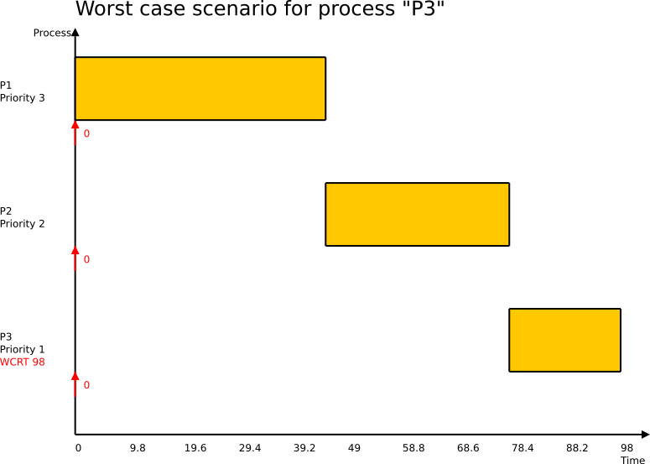
Figure 16: Visualization of analysis results

The XML representation of the SVG file is shown here (repeated sections have been cut out):
<?xml version="1.0" encoding="ISO-8859-1" standalone="no"?>
<svg xmlns="http://www.w3.org/2000/svg" id="body" width="800" height="600" viewBox="0 0 800 600">
<line x1="100" y1="75" x2="100" y2="550" style="stroke:rgb(0,0,0);stroke-width:2" />
<line x1="100" y1="550" x2="775" y2="550" style="stroke:rgb(0,0,0);stroke-width:2" />
<polygon points="775,545 785,550 775,555"/>
<polygon points="95,75 100,65 105,75"/>
<text style="fill:black; font-size:24" x="100" y="50">Worst case scenario for process "P3"</text>
<text x="50" y="75">Process</text>
<text x="750" y="585">Time</text>
<text x="100" y="570">0</text>
<text x="165" y="570">9.8</text>
...
<text x="750" y="570">98</text>
<line x1="100" x2="100" y1="175" y2="205" style="stroke:red;stroke-width:2" />
<polygon points="95,185 100,175 105,185" style="fill:red" />
<text style="fill:red;" x="110" y="195">0</text>
<text x="10" y="137.5">P1</text>
<text x="10" y="152.5">Priority 3</text>
<line x1="100" x2="100" y1="325" y2="355" style="stroke:red;stroke-width:2" />
...
<text style="fill:red;" x="10" y="467.5">WCRT 98</text>
<rect style="fill:rgb(255,200,0)" width="298.469" height="75" x="100" y="100"/>
<line x1="100" y1="100" x2="398.469" y2="100" style="stroke:rgb(0,0,0);stroke-width:2" />
<line x1="100" y1="175" x2="398.469" y2="175" style="stroke:rgb(0,0,0);stroke-width:2" />
<line x1="100" x2="100" y1="100" y2="175" style="stroke:rgb(0,0,0);stroke-width:2" />
<line x1="398.469" x2="398.469" y1="100" y2="175" style="stroke:rgb(0,0,0);stroke-width:2" />
...
</svg>

The tool also writes the worst-case response time of each process into a text file, which is then loaded by the interpreter, which sets the WCRT attribute for each process in GME (see Figure 17).

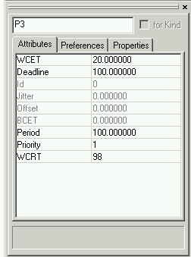
Figure 17: P3 attributes after the analysis

Conclusions and future work

Conclusions
We have started with a simple model of an embedded system, to show how it is possible to add a user interface, and we have used as an example the “holistic” tool integration in GME. Then, we have taken the model of an embedded real-time system introduced in MAST, which is general enough to cover any type of embedded system analyzed by the tools at ESLAB. We have created a meta-model for this, and we have shown how the meta-model can be used to successfully model hierarchical schedulers analyzed by the “hierarchical” tool.

Future work
The MAST meta-model is a part of a systematic approach to the integration of ESLAB’s tools into GME. Future work in this area could include:

- Making the meta-model more structured. This could be done by grouping the entities into aspects (for example, hardware, software and application aspects like in AIRES).
- A more general approach to the integration of ESLAB’s tools into GME.

References

- W. Wolf, Computers as Components: principles of embedded computing system design. 2001, Morgan Kaufmann Publishers.
- G. Leen, Donal Heffernan, ”Expanding Automotive Electronic Systems,” in IEEE Computer, pages 88-93, January 2002.
- P. Pop, Analysis and Synthesis of Communication-Intensive Heteregeneous Real-Time Systems. 2003, Linköpings Universitet.
- M. Chiodo, ”Automotive Electronics: A Major Application Field for Hardware-Software Co-Design,” in Hardware/Software Co-Design, Kluwer Academic Publishers, pages 295– 310, 1996.
- T. Clark, A. Evans, P. Sammut, J. Willans, Applied Meta-modelling: a foundation for language driven development. 2004, Xactium.
- H. Kopetz, Real-Time Systems-Design Principles for Distributed Embedded Applications, Kluwer Academic Publishers, 1997.
- A. Burns, A. Wellings. Real-Time Systems and Programming Languages. 2001, Addison Wesley.
- T. Pop, P. Eles, Z. Peng, “Holistic Scheduling and Analysis of Mixed Time/Event-Triggered Distributed Embedded Systems”, 10th International Symposium on Hardware/Software Codesign, 2002, pages 187-192.
- T. Pop, P. Pop, P. Eles, Z. Peng, “Optimization of Hierarchically Scheduled Heteregeneous Embedded Systems”, 11th IEEE International Conference on Embedded and Real-Time Computing Systems and Applications, 2005, pages 67-71.
- A. Hamann, R. Henia, R. Racu, M. Jersak, K. Richter, R. Ernst, SymTA/S – Symbolic Timing Analysis for Systems, http://cse.unl.edu/ecrts04wip/proceedings/5-Hamann.pdf, 2004.
- AIRES Toolkit User Manual. http://kabru.eecs.umich.edu/aires/, 2001.
- AIRES. http://www.escherinstitute.org/tools/basic/aires, 2005.
- Modeling and Analysis Suite for Real-Time Applications. http://mast.unican.es/, 2004.
- GME Technical Overview. http://www.isis.vanderbilt.edu/Projects/gme/tech.html, 2005.
- R. Miller, Practical UML™: A Hands-On Introduction for Developers. http://bdn.borland.com/article/0,1410,31863,00.html, 2003
- GME tutorials. http://www.isis.vanderbilt.edu/Projects/gme/Tutorials/, 2005.
- Description of the MAST Model. http://mast.unican.es/mast_description_xml.pdf, 2004.
- Scalable Vector Graphics (SVG). http://www.w3.org/Graphics/SVG/, 2005.
- D. Bell, Software Engineering. 2000, Addison Wesley.
- F. Swartz, Java Notes. http://leepoint.net/notes-java/index.html, 2005.
- Microsoft Foundation Class Library. http://msdn.microsoft.com/library/default.asp?url=/library/en-us/vcmfc98/html/mfchm.asp, 1998.

